DoS

* Tanishk Singh

Purpose: -

The aim behind performing this lab was to understand the principles of a *Denial of Service attack*. This lab was performed for educational purposes and with the intent to use the skills learned through this lab for good. There are numerous kinds of Denial of Service attacks out there, and I would perform a *Wi-Fi Deauthentication attack* to fulfill the purpose of this lab.This lab was performed virtually using two applications, which enable the user to work in a virtual environment, called *VMWare Workstation* and *GNS3*. I performed this lab virtually because my places of work were shut down due to the “COVID-19 Pandemic,” which had affected the whole world when I performed this lab. So, this lab would be carried out to also learn to adapt to different situations and manage the workload responsibly. A type of Linux OS, called the *Deepin Linux*, was used as the attacking host, and I would also learn to run some specific Linux commands and scripts on the Deepin OS.

Background Information: -

A Denial of Service attack *(or DoS attack)* is a cyber attack that the perpetrators use to disable a machine’s or a network’s resources. Attackers usually perform a DoS attacks on servers of enterprise companies to bring them down. A DoS attack is performed by sending the to-be infected host numerous packets of a kind, hence, causing an overload on that machine, and due to the overload, the machine would be unable to operate at its usual strength or it might just fail to perform at all. Due to the advanced hardware features available nowadays, it is extremely hard for the attackers to perform a successful DoS attack through just one attacking host. That is why attackers in today’s day and age use multiple attacking hosts to attack a single machine to effectively cause an overload. The type of DoS attack, in which the attackers use numerous hosts to infect a machine or network is known as *Distributed Denial of Service (or DDoS attack)*. The DoS and the DDoS attacks are very lethal cyber attacks. These attacks flood the network’s bandwidth, and when they are executed on a person’s network or machine, there is little that person can do to stop or even mitigate the attack. Some common types of DoS/DDoS attacks are *ICMP (Ping) Flood, SYN Flood, Ping of Death, Slowloris, NTP Amplification, HTTP Flood* and *Zero-day DDoS Attacks*. The attack that is covered in this lab is known as a Wi-Fi Deauthentication attack *(or a wi-fi deauth attack)*.

A Wi-Fi Deauth attack is a type of DoS/DDoS attack, which targets the connections made to a *Wireless Access Point (or WAP)*. A WAP is wired into a router that connects to the ISP’s topology, and it can grant its users access to the internet either wirelessly or through a wired connection. The attackers flood the WAP with *Deauthentication frames*, which are used to deauthenticate a user from the WAP. This attack can be used in different ways. The attacker can either use this attack to deauthenticate everyone connected to the WAP or deauthenticate a specific host from the WAP. The best Linux tool to use to perform this attack is the *Aircrack-ng suite.*

Aircrack-ng is a network software suite consisting of a detector, packet sniffer, WEP and WPA/WPA2-PSK cracker and analysis tool for 802.11 wireless LANs. It works with any network interface controller, whose driver supports raw monitoring mode and can sniff 802.11a, 802.11b and 802.11g traffic. The program runs under Linux, FreeBSD, macOS, OpenBSD, and Windows. The suite consists of 16 features. I would use 4 of the 16 features: -

1. Aircrack-ng: Cracks Wi-Fi authentication keys
2. Airmon-ng: Places different cards in monitor mode
3. Aireplay-ng: injects packet
4. Aerodump-ng: Places air traffic into pcap or IVS files and shows information about networks.

The intention behind the suite’s creation was to help recover Wi-Fi passwords, but people have figured out a way to carry out their evil plans. Although one can catch the attacker red-handed by analyzing the attacking host’s MAC address mentioned in the deauthentication frames, the attacker can spoof/fake their MAC address using a tool called *Macchanger.* Macchanger is a tool used to fake or spoof a network interface’s mac address. A professional hacker would always use this tool or any other similar tool to hide their identity while performing any kind of attack. These tools were downloaded and executed on a virtual machine operating on Deepin Linux.

Deepin (formerly known as Linux Deepin and Hiweed Linux) is a Linux distribution based on Debian's stable branch. Deepin is known for its desktop environment, knwn as Deepin desktop environment (or DDE). The DDE includes numerous Deepin applications that are built via C++ and Qt. Among the multiple application included in Deepin’s desktop environment, is the Deepin terminal, which has received praise for its smooth workflow. This lab would be completed virtually on GNS3 and VMWare.

*Graphical Network Simulator-3* (shortened to GNS3) is a network software emulator, which was first released in 2008. It allows the combination of virtual and real devices, used to simulate complex networks. Unlike Cisco’s Packet Tracer, which is preconfigured to let the users have access to the virtual routers, switches, etc., in GNS3, the user would need to add the virtual nodes by importing their image files onto the application. GNS3 allows the user to configure the imported router/switch as they would on a real device, without any restriction. GNS3 supports another software that is used to deploy virtual machines on an end host, called VMWare Workstation. VMWare Workstation is a hypervisor service that enables its users to deploy VM(s) on a physical machine and use them simultaneously with the actual machine. VMWare Workstation is currently in its 15th version. GNS3 and VMWare Workstation are two applications that can work together and support each other. A VM deployed on VMWare can become a part of a GNS3 topology, and GNS3 has a server that can be downloaded from the organization’s website, known as *GNS3 VM*, which can be deployed on VMWare. GNS3 VM is a local server that can be installed from GNS3’s website and can be deployed on VMWare. It is recommended to install GNS3 VM and run the virtual appliances through that server because by doing so, the virtual appliances will run on the GNS3 VM’s workload rather than the user’s PC’s workload. It eliminates the risk of overheating and destroying the user’s physical PC’s RAM and CPU. GNS3 VM becomes a requirement if the user needs advances services like QEMU VMs and advances IOSv images. The user must note, however, that VMWare workstation is an application that can only operate on Windows and Linux machines. People using Apple’s Mac OSX, must install *VMWare Fusion*, which is an alternative of VMWare Workstation for Mac OSX users. Since I would be using a router to connect my Deepin VM to the internet, I had to use *NAT*.

Network address translation (NAT) is a method of remapping one IP address space into another by modifying network address information in the IP header of packets while they are in transit across a traffic routing device. It is a routing protocol, which is used to create a public IP address to be sent out of the router, whilst keeping the user’s private IP address intact. It is not only a secure method of surfing on the internet, but also required in today’s day and age. We have currently run out of IPv4 addresses. To continue using IPv4 addresses on the internet, without having a mismatch, ISPs use an extension of NAT, called *PAT*. Port Address Translation (or PAT) is an extension of NAT that enables multiple IP addresses in a LAN to be mapped to a single public IP address. Due to this skill, an entire neighborhood can surf on the internet using one single IP address. Moreover, NAT/PAT is required to create a connection with an outside LAN.

Lab Summary

I started the lab by installing GNS3 and VMWare Workstation 15 on my Windows 10 PC. Although VMWare Workstation is a subscription-based service, Newport High School, the high school that I am a student of, gave its students, enrolled in IT courses, the opportunity to download the software for free. GNS3, on the other hand, also has a premium service, but its free service is more than enough to complete this lab. After I had successfully installed both the applications, I downloaded the GNS3 VM file from GNS3’s website and executed it on VMWare Workstation.

I, later, had to research on google to download some Cisco router IOS images, which would later become a part of my GNS3 topology. After that, I downloaded various Linux distributed OS as I was a little hesitant with downloading the Deepin OS due to the rumors surrounding the OS. I eventually downloaded and began using the Deepin OS as I had decided that I wanted to gain some experience working with the DDE.

Once I was done downloading all the resources, I created a topology that does not look like the one down below. The topology image below shows components of GNS3 as well as components of the physical topology. I created another interface on the GNS3 VM, which would replicate my physical topology, and then created a cloud on the GNS3 topology, which I connected to that interface of GNS3 VM. I connected the cloud to a router, and then deployed the Deepin VM on GNS3 and connected it to the router. I had to do PAT (NAT overload) on the router to have it connect with the WAP. After my Deepin could make a connection with the WAP, I opened the Terminal in the VM and started downloading the Aircrack-ng suite and the Macchanger tool. At that point, I made a *script* on the terminal and had it operate on loop. The script was written in a way, due to which, I could send numerous deauthentication frames to the WAP in an instant. The attack using a script made it look sort of like a DDoS attack. After a while, every user connected to my WAP was seen having trouble connecting to the internet.

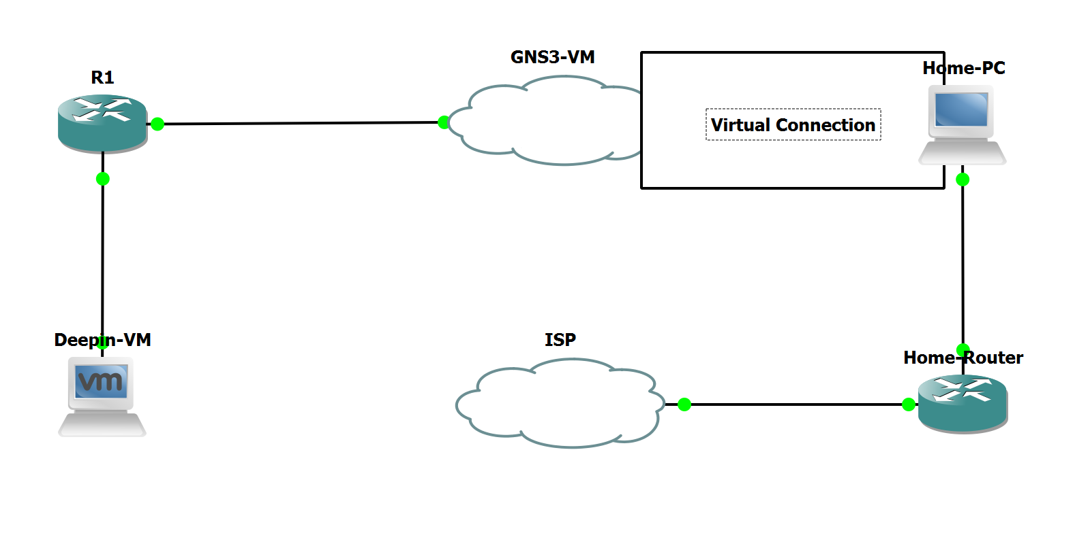Topology and IP Address table

## procedure and results

## Step 1: -

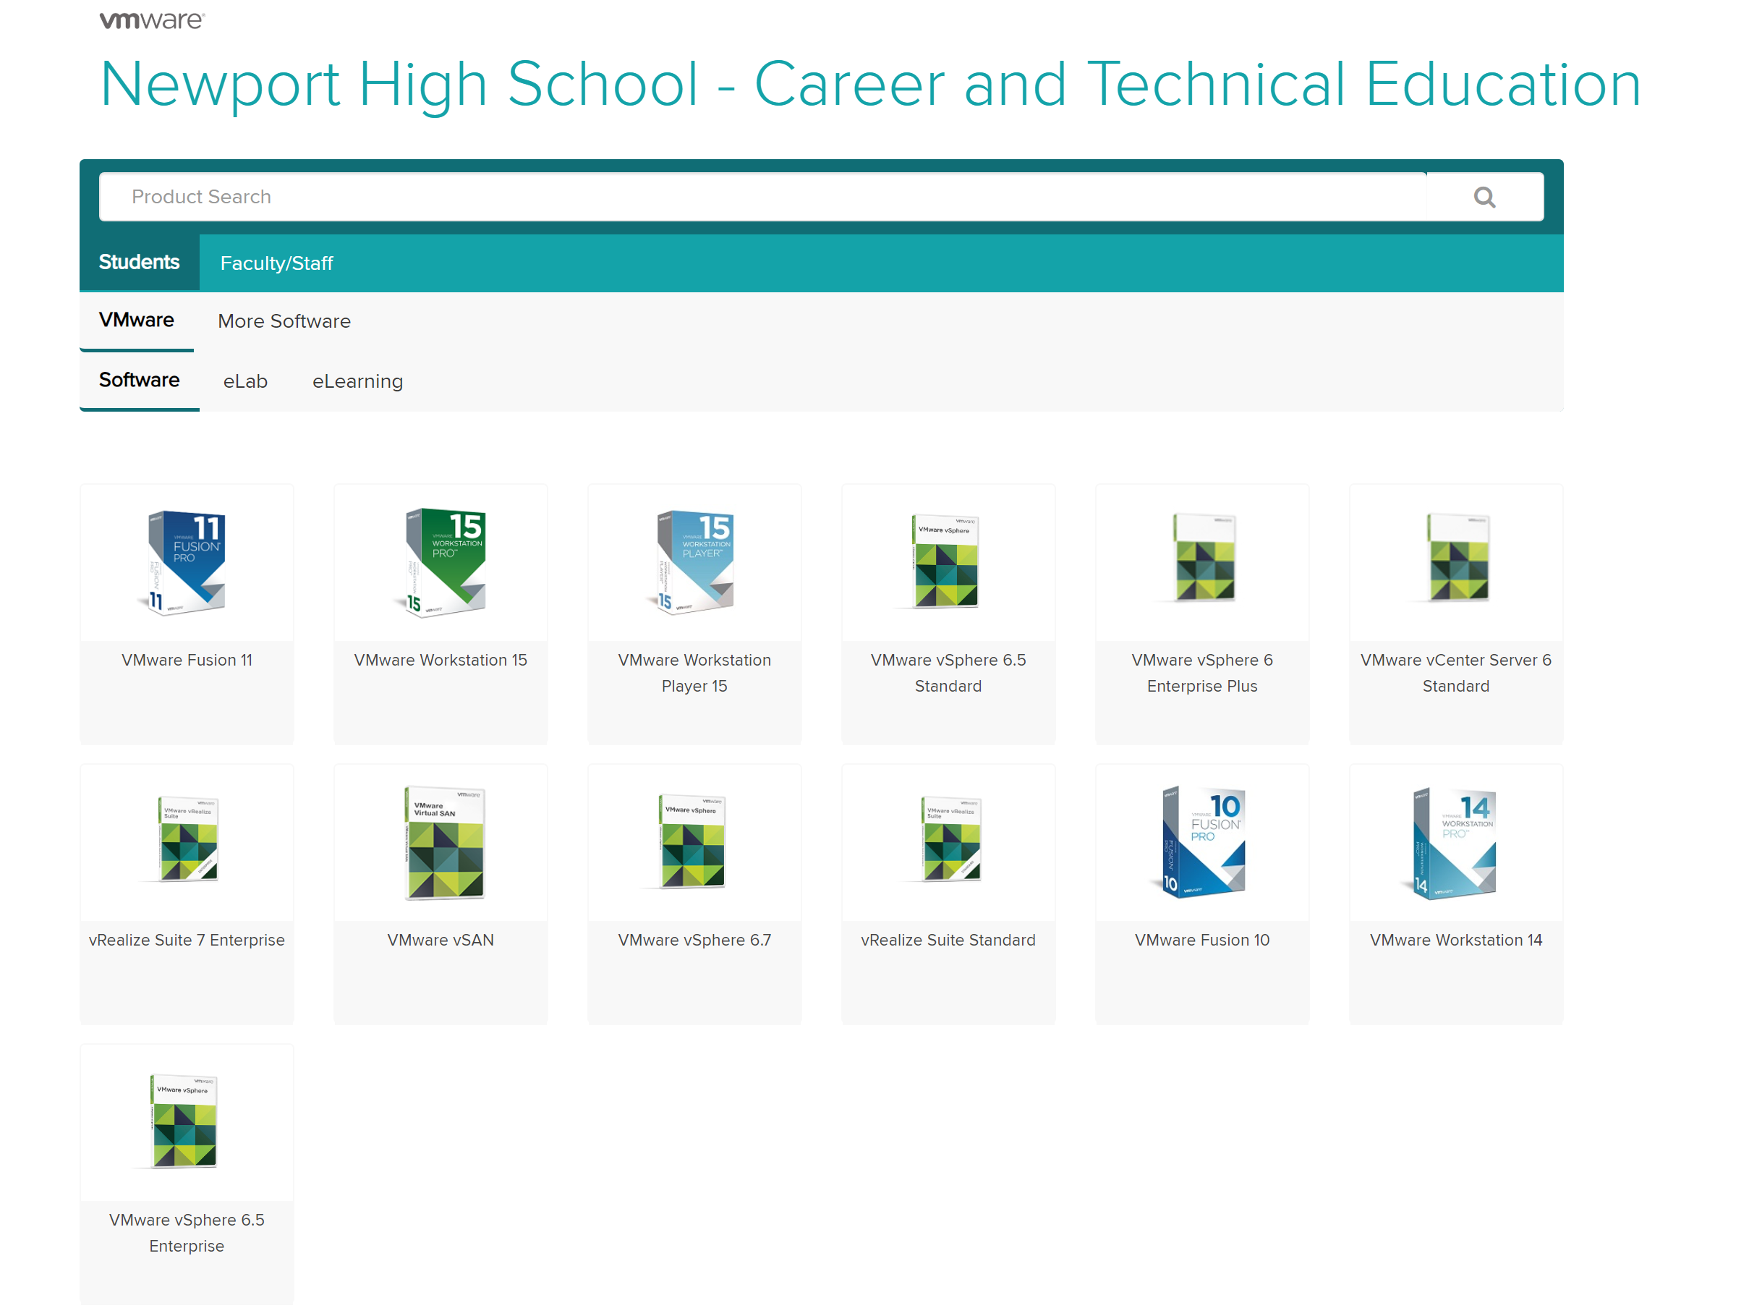

Download VMWare Workstation/Fusion on your end host. This is a capture of the service provided to Newport High School’s students, where they could download the software for free.

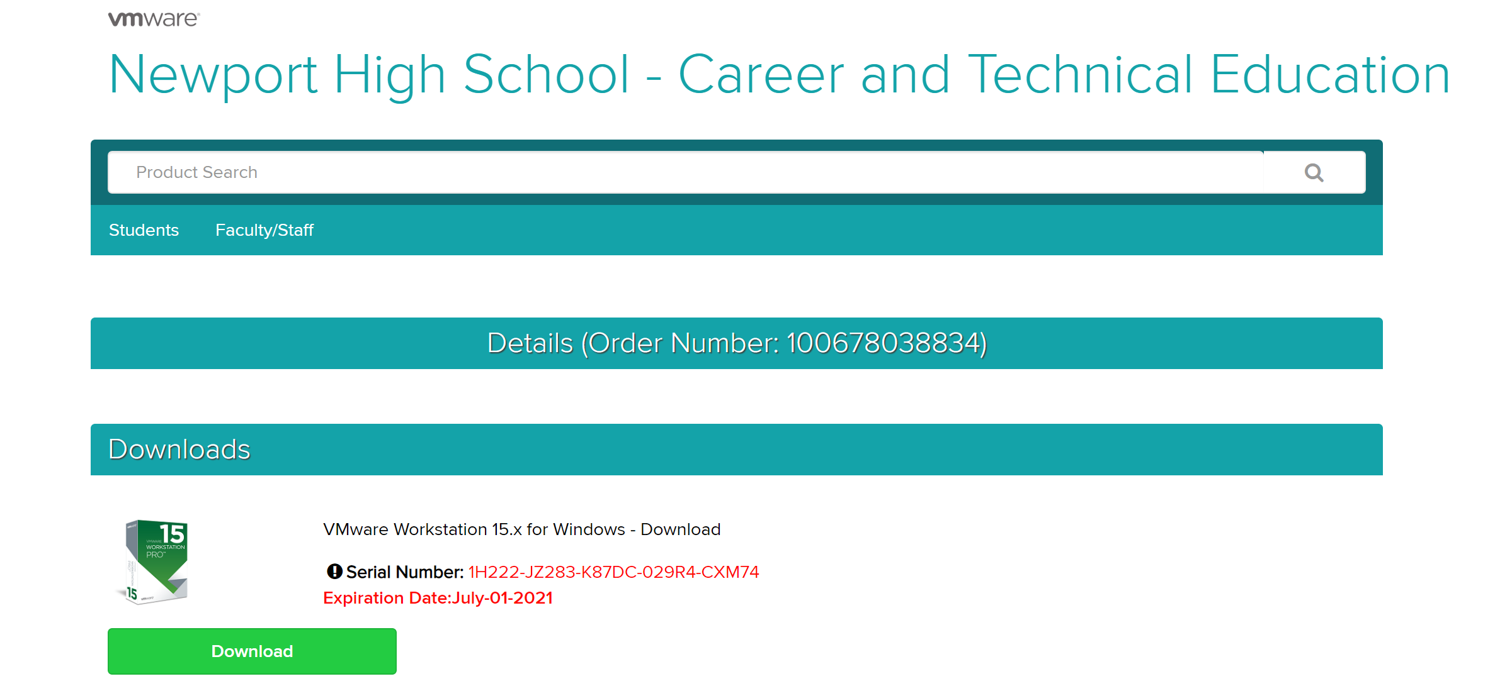

Once the order is confirmed, the website will guide the user to a section that mentions the serial number of the order and the product’s expiration date. The serial number is something that MUST be noted or screenshotted.

## Step 2: -

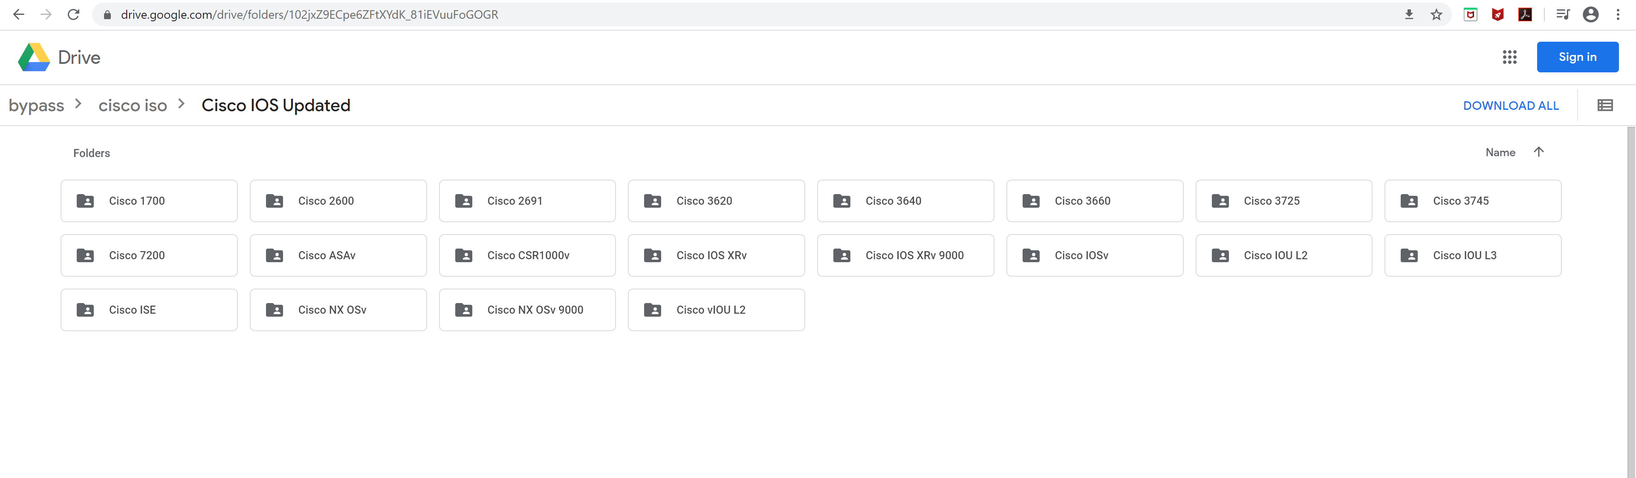

Before downloading GNS3, the user should have the Cisco IOS images that they need to complete their task. Go to the red highlighted link on the address bar. The link contains images and files of almost all the Cisco appliances that can be installed in GNS3. The user does not need to download all the files from the google drive link, but they must download one of the files highlighted in blue color. Those files carry their respective Cisco router IOS images. We need at least one router deployed on GNS3 in order to complete this lab.

## Step 3: -



Now the user would want to install GNS3 on their PC. Before the downloading GNS3’s setup file, the user must either create an account on GNS3’s website or log in to an existing account.

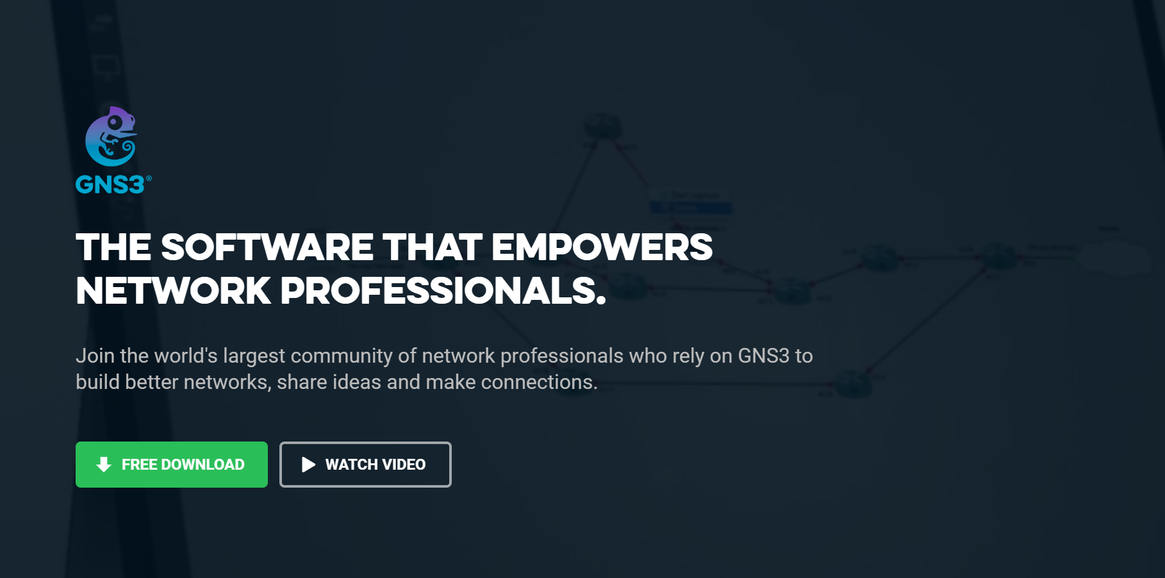

Once the user logs in to their account on GNS3’s website, they will be prompted to download the software for free. Click on the green “free download link.”

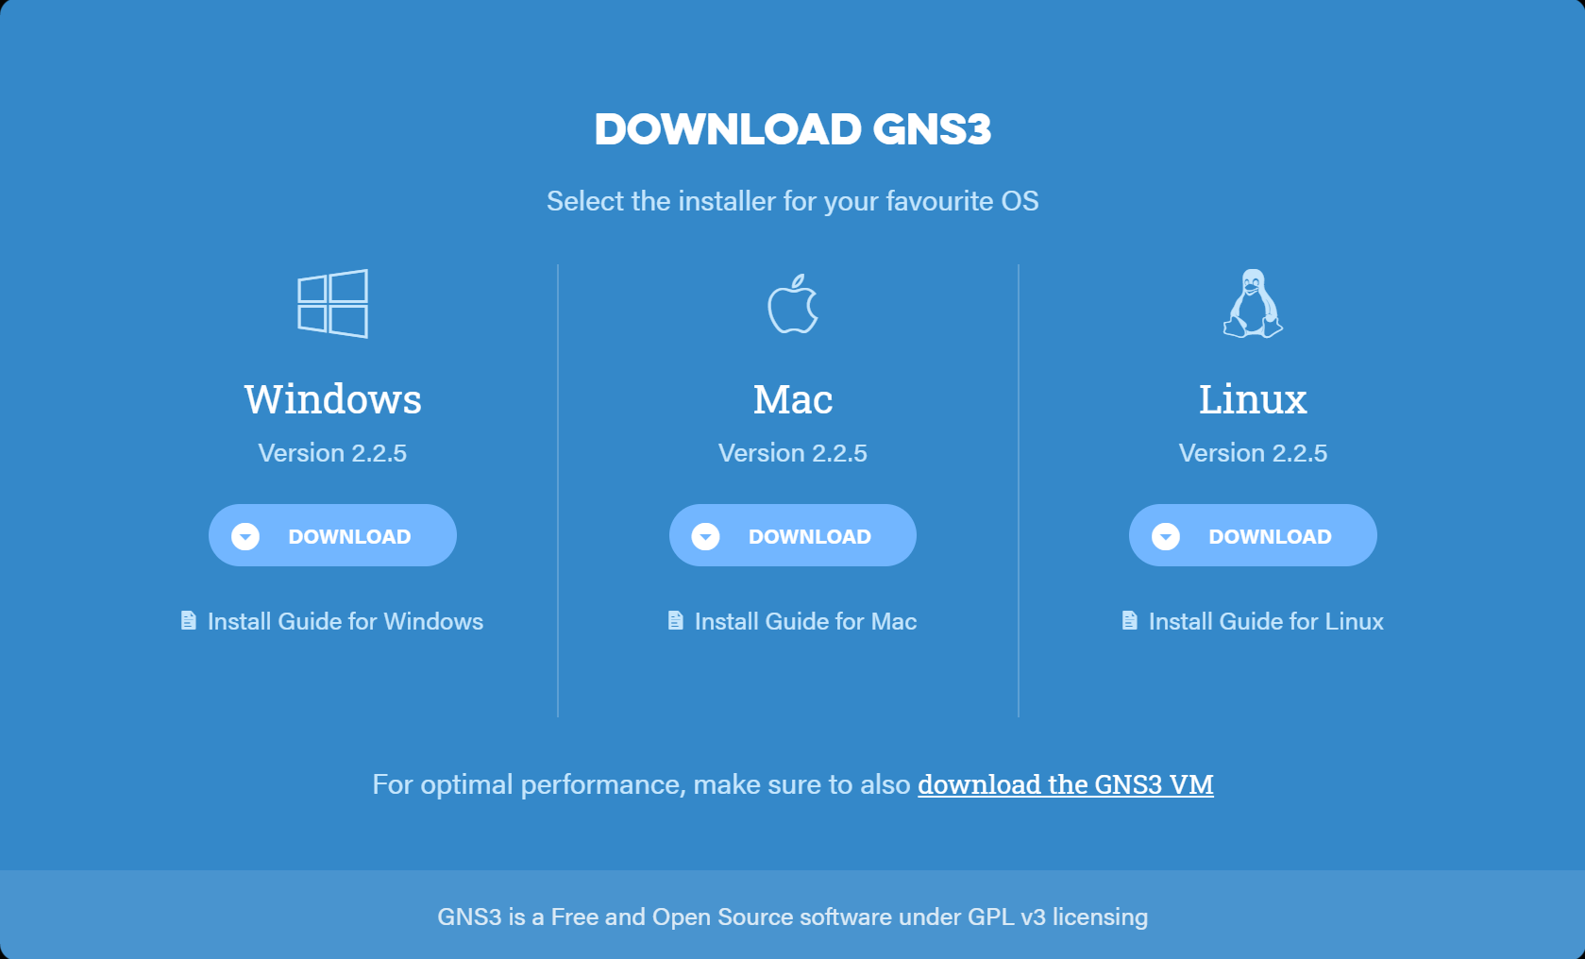

Choose your Operating Software as the setup file for all three OS differs, and the setup will not be downloaded successfully if there is an OS mismatch.

The user should, then, start the setup and successfully install GNS3 on their PC.

## Step 4: -



Once GNS3 has been installed and started for the first time, it will probably spawn numerous errors. That is fine as it probably is not able to connect to GNS3 VM. To download and deploy the GNS3 VM, open the GNS3 application and navigate to help -> setup wizard

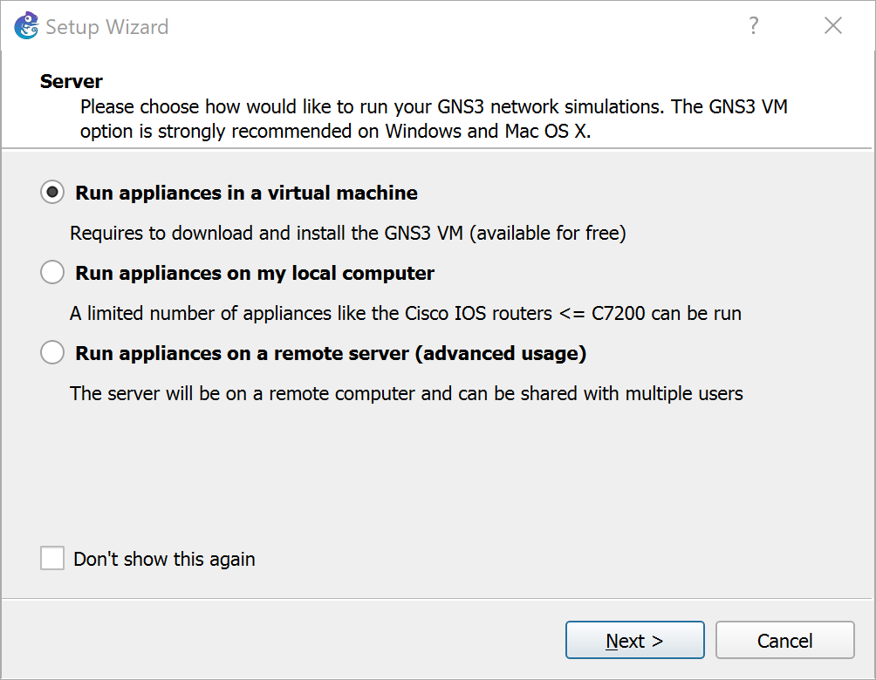

To download the GNS3 VM, the user must select the “run appliances in a virtual machine” option.

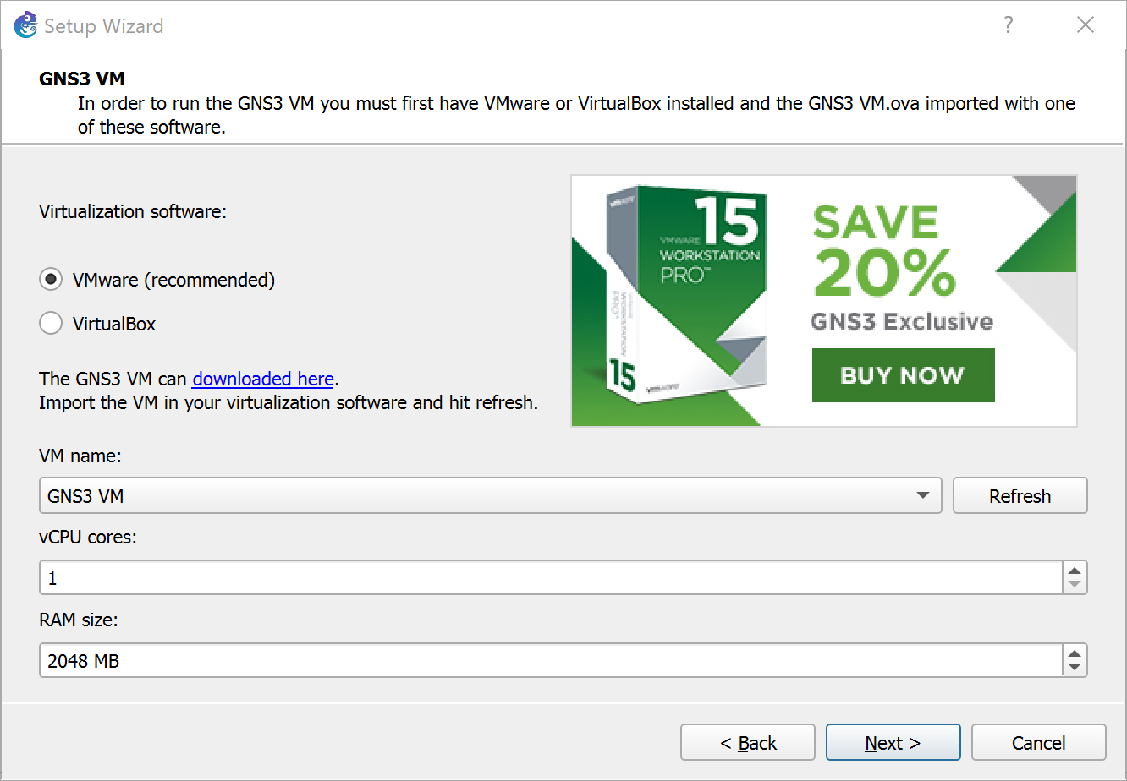

The user will then be prompted to the window that looks somewhat identical to the screenshot above. The user would need to click on the “download here” option, which has also been highlighted in a rectangle, to download the GNS3 VM file. At this point, the user should cancel the setup wizard and let the GNS3 VM file download.

## Step 5: -

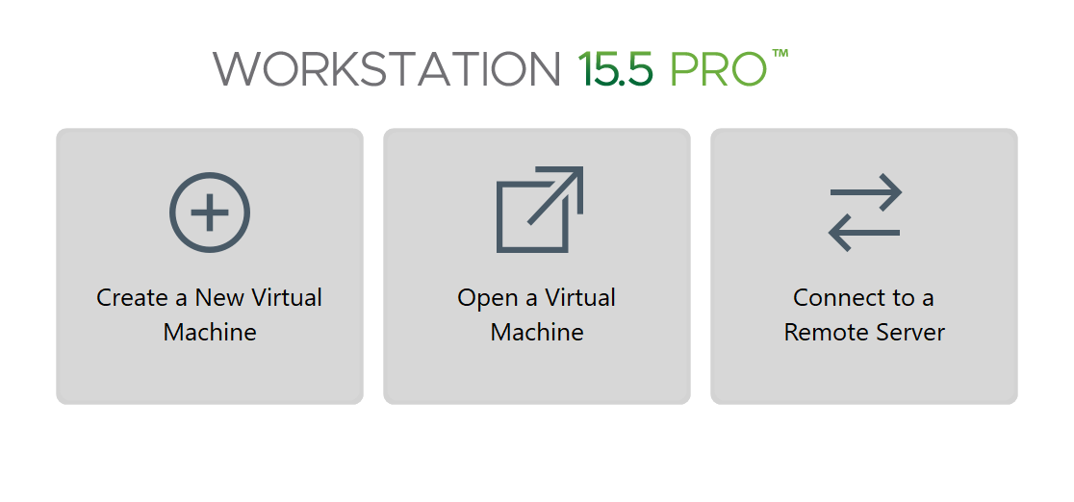

After the GNS3 VM file has been downloaded, open VMWare Workstation/Fusion and click on the “open a virtual machine” option. Locate the GNS3 VM file, which was downloaded in the previous step, and start the VM.

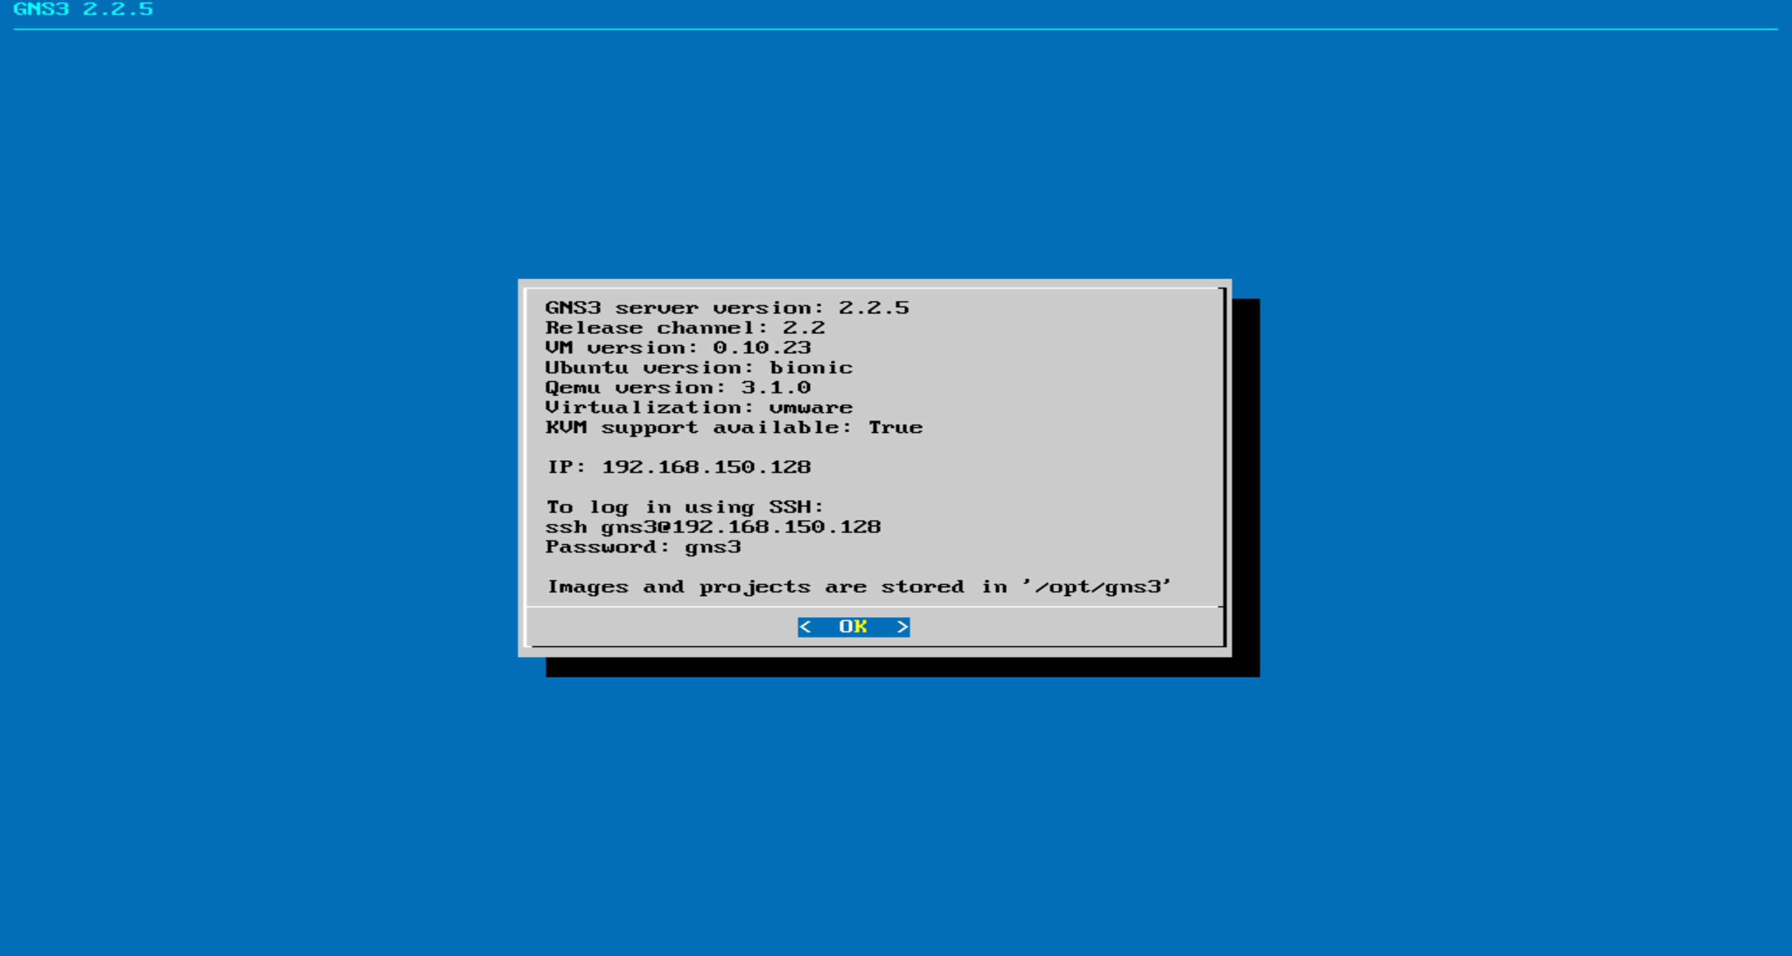

After the VM has been installed on VMWare Workstation, hit “OK.”

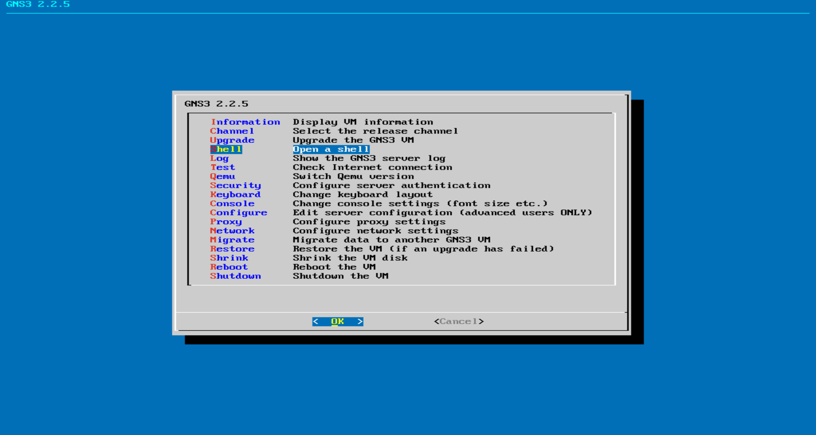

Use the arrow keys to navigate to the option “shell.”



Once the shell has opened, the user would want to run a few commands to update, and upgrade the GNS3 VM. The first one of them is sudo apt update. This command will download and install any update available for the VM.



The second command is the sudo apt upgrade command. This command will download any upgrade for the VM.

## STEP 6: -

Now open the GNS3 setup wizard again by repeating step 4, and this time, the user’s window should look exactly identical to the following screenshot.



Click on “next.”

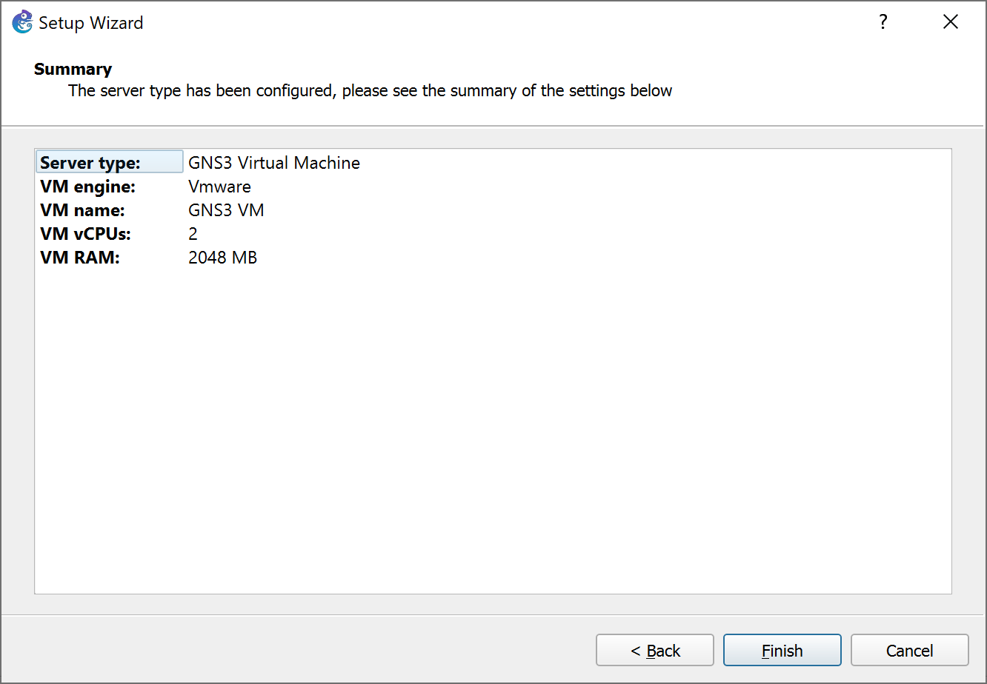

GNS3 would have automatically detected the GNS3 VM running on VMWare, and the user would not need to do anything else. Click “finish” to complete the setup.

## Step 7: -

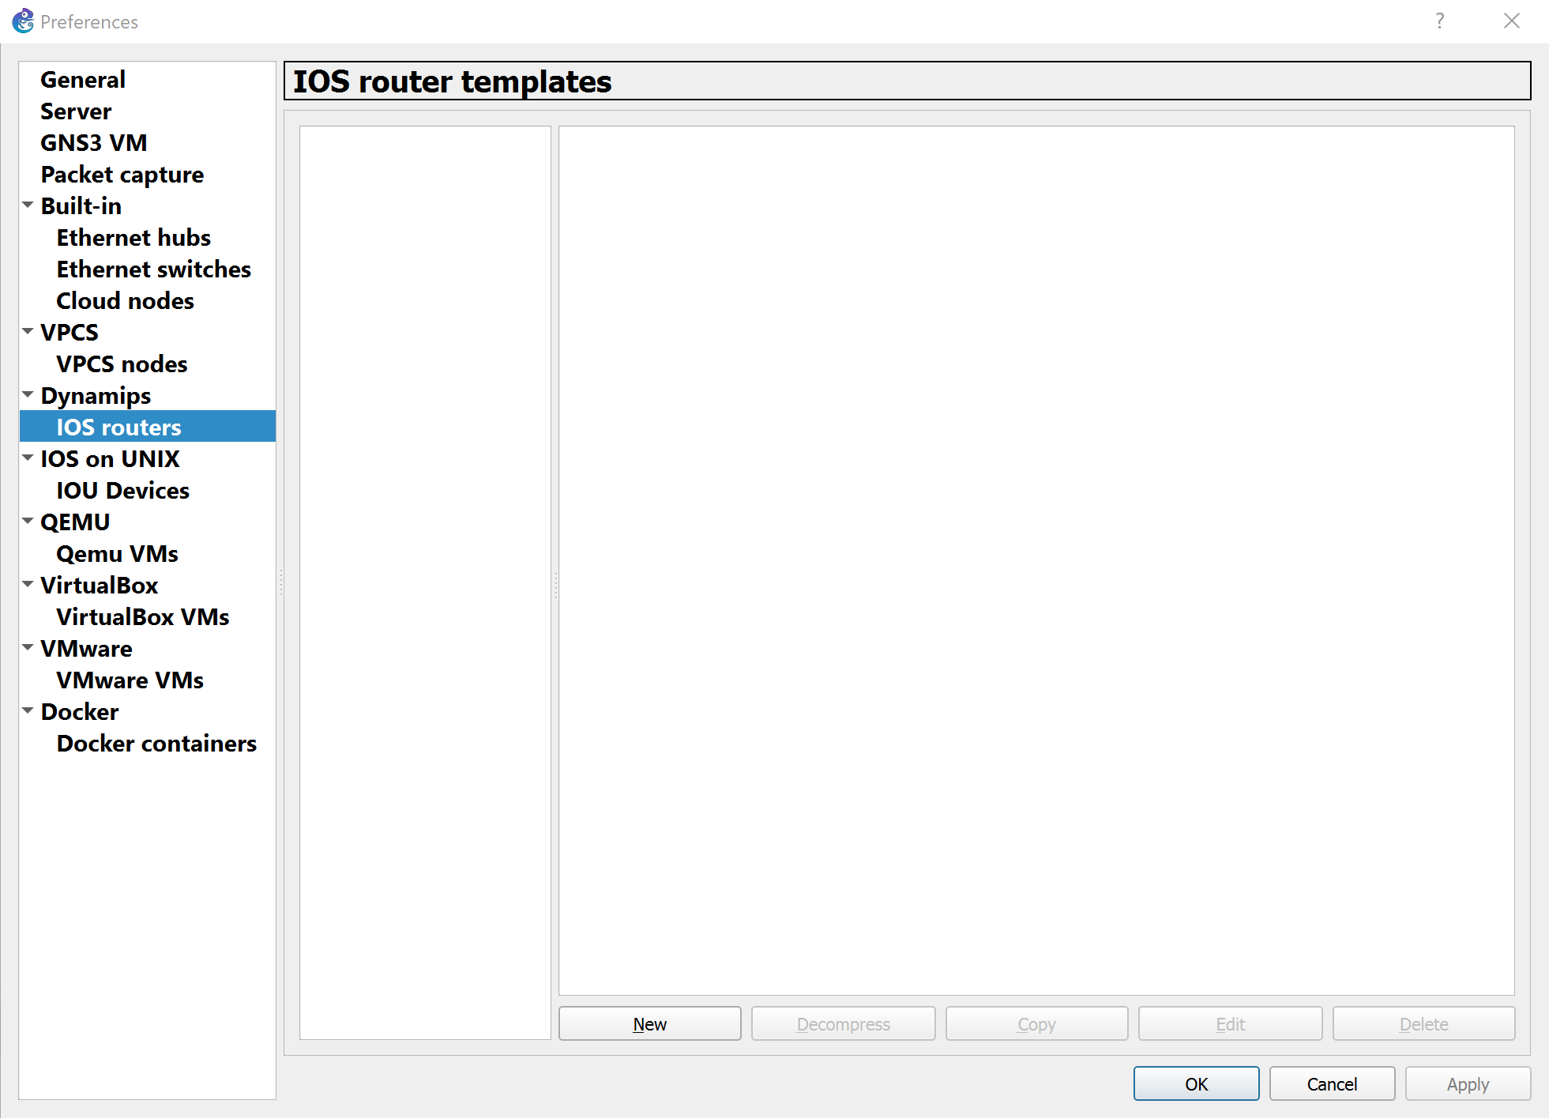

Now the user should begin importing one of the IOS images of the Cisco router downloaded from the Google drive link. The user must navigate to edit -> preferences, and under “Dynamips,” locate “IOS routers” and click on “New.”

## Step 8: -

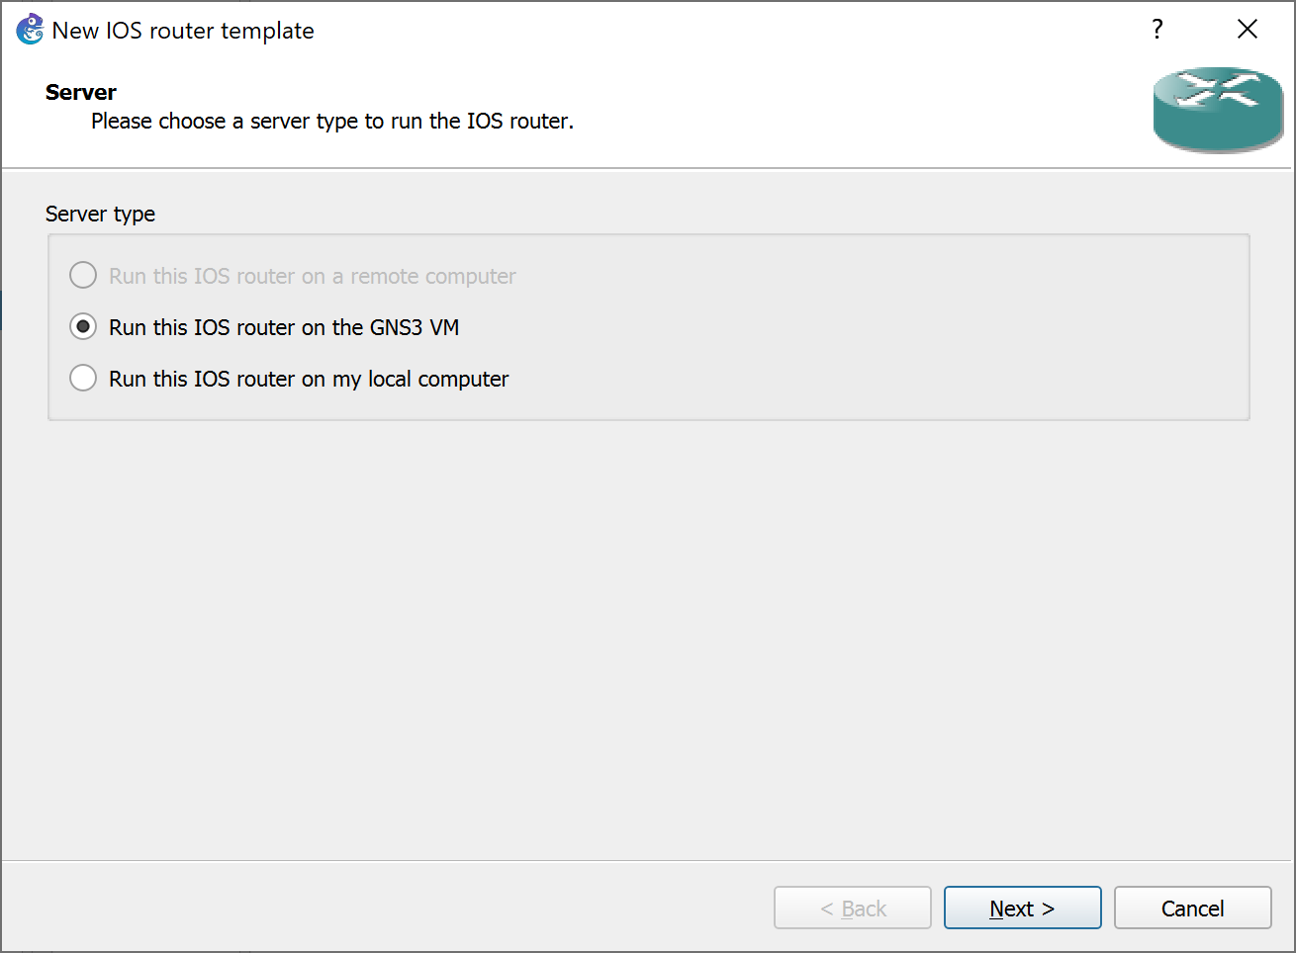

To prevent the Physical machine that is running the application to carry the huge load of the virtual appliances, select “Run this IOS router on the GNS3 VM” to run the appliances through GNS3 VM.

## Step 9: -

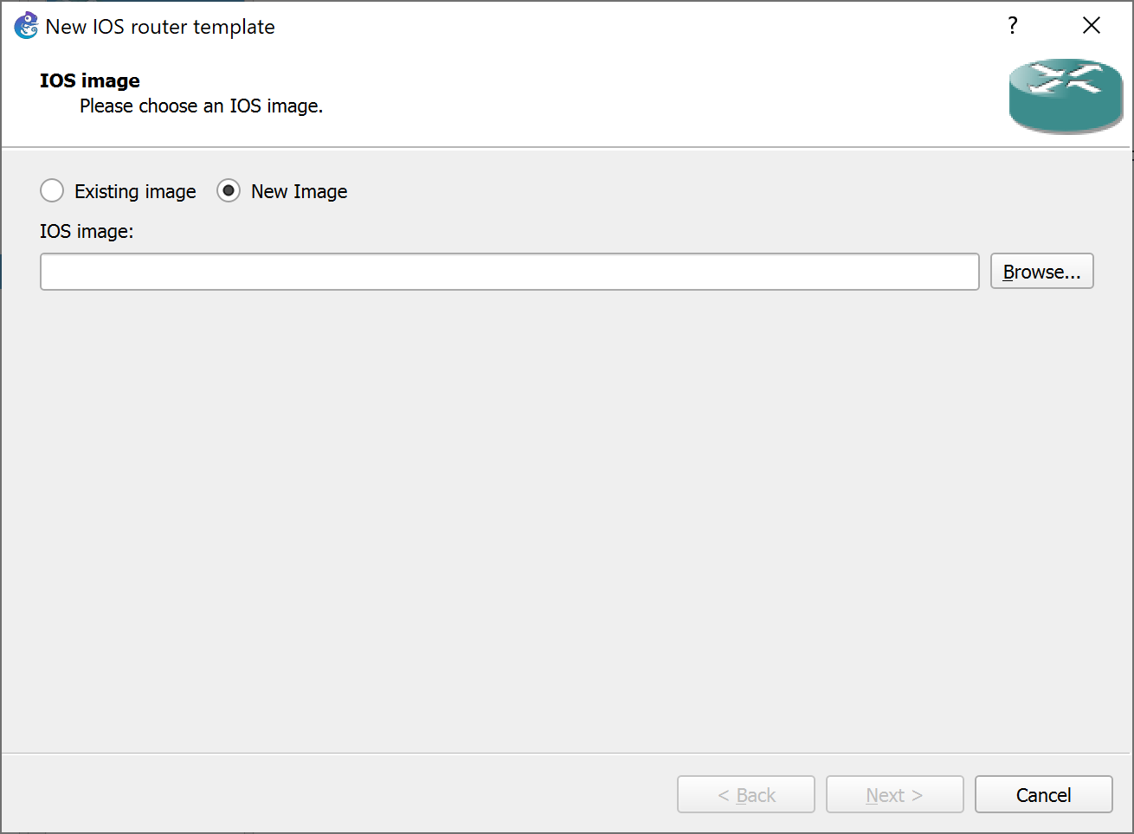

Click on “New Image” to begin the import a new IOS image, and “Browse…” to locate the IOS image that needs importing.

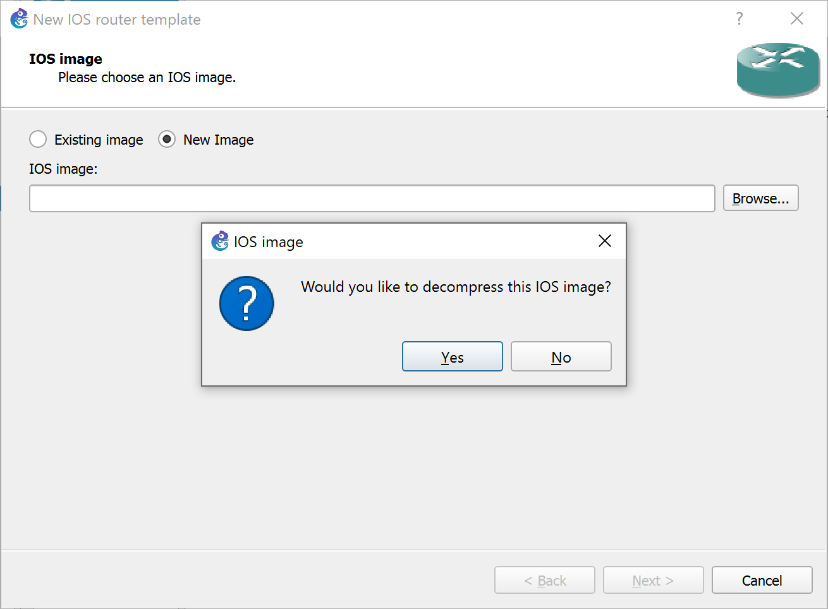

After locating the image, GNS3 will ask the user if they want to decompress the image. If the user’s PC has enough memory, then they should opt to not decompress the image. If the image is decompressed in the directory, it can cause the appliance to perform at a slow pace.

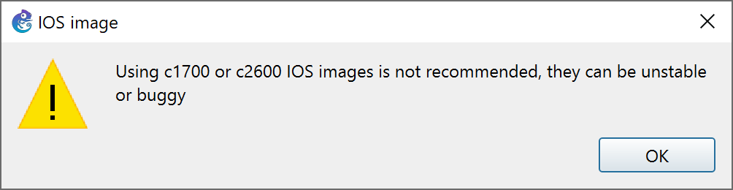  
 GNS3 will show this warning sign if the user attempts to import a c1700 series image or a c2600 series image. There is not much to worry about these images as GNS3 shows this warning sign because those images are fairly old and there is always a possibility of them crashing when they receive or send heavy packets. They, however, would do just fine for this lab.

## Step 10: -

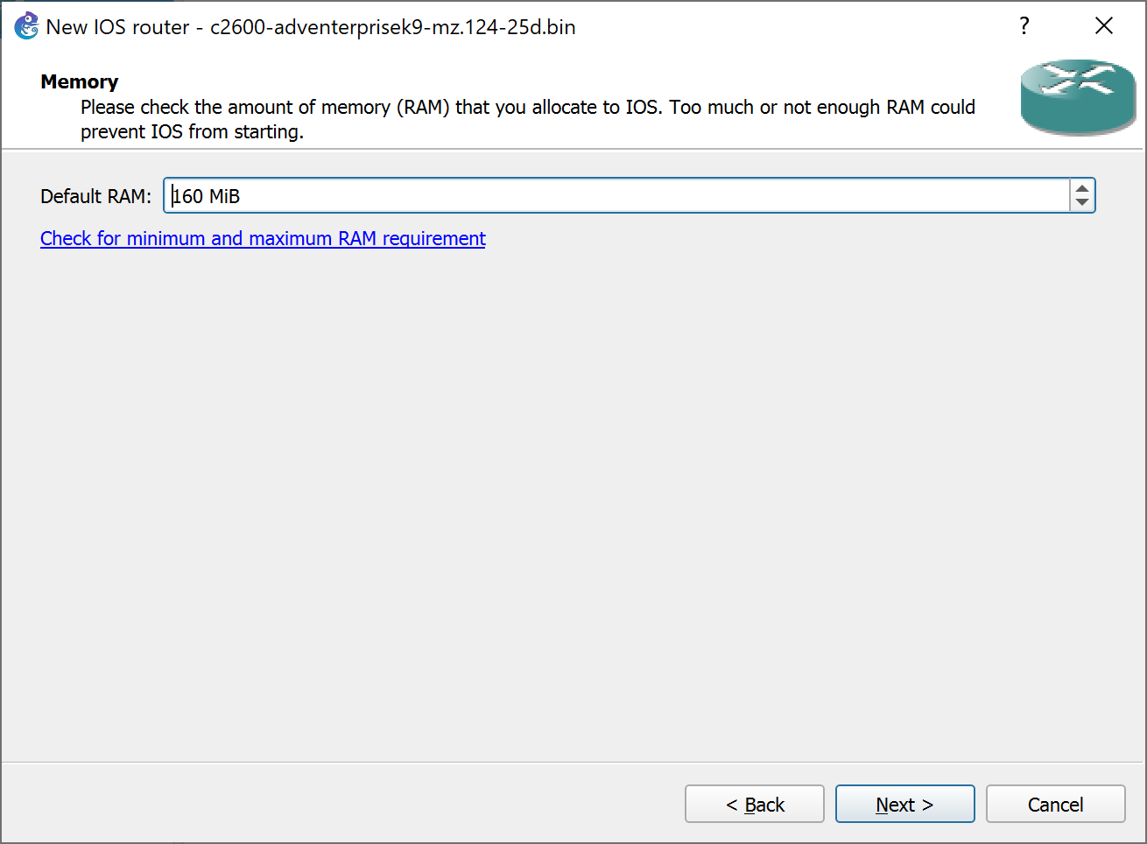

After the previous step is completed, the user would be guided to this screen. The user should never guess or estimate the value of the any appliances’ RAM. The user should click on the “Check for minimum and maximum RAM requirement” link.

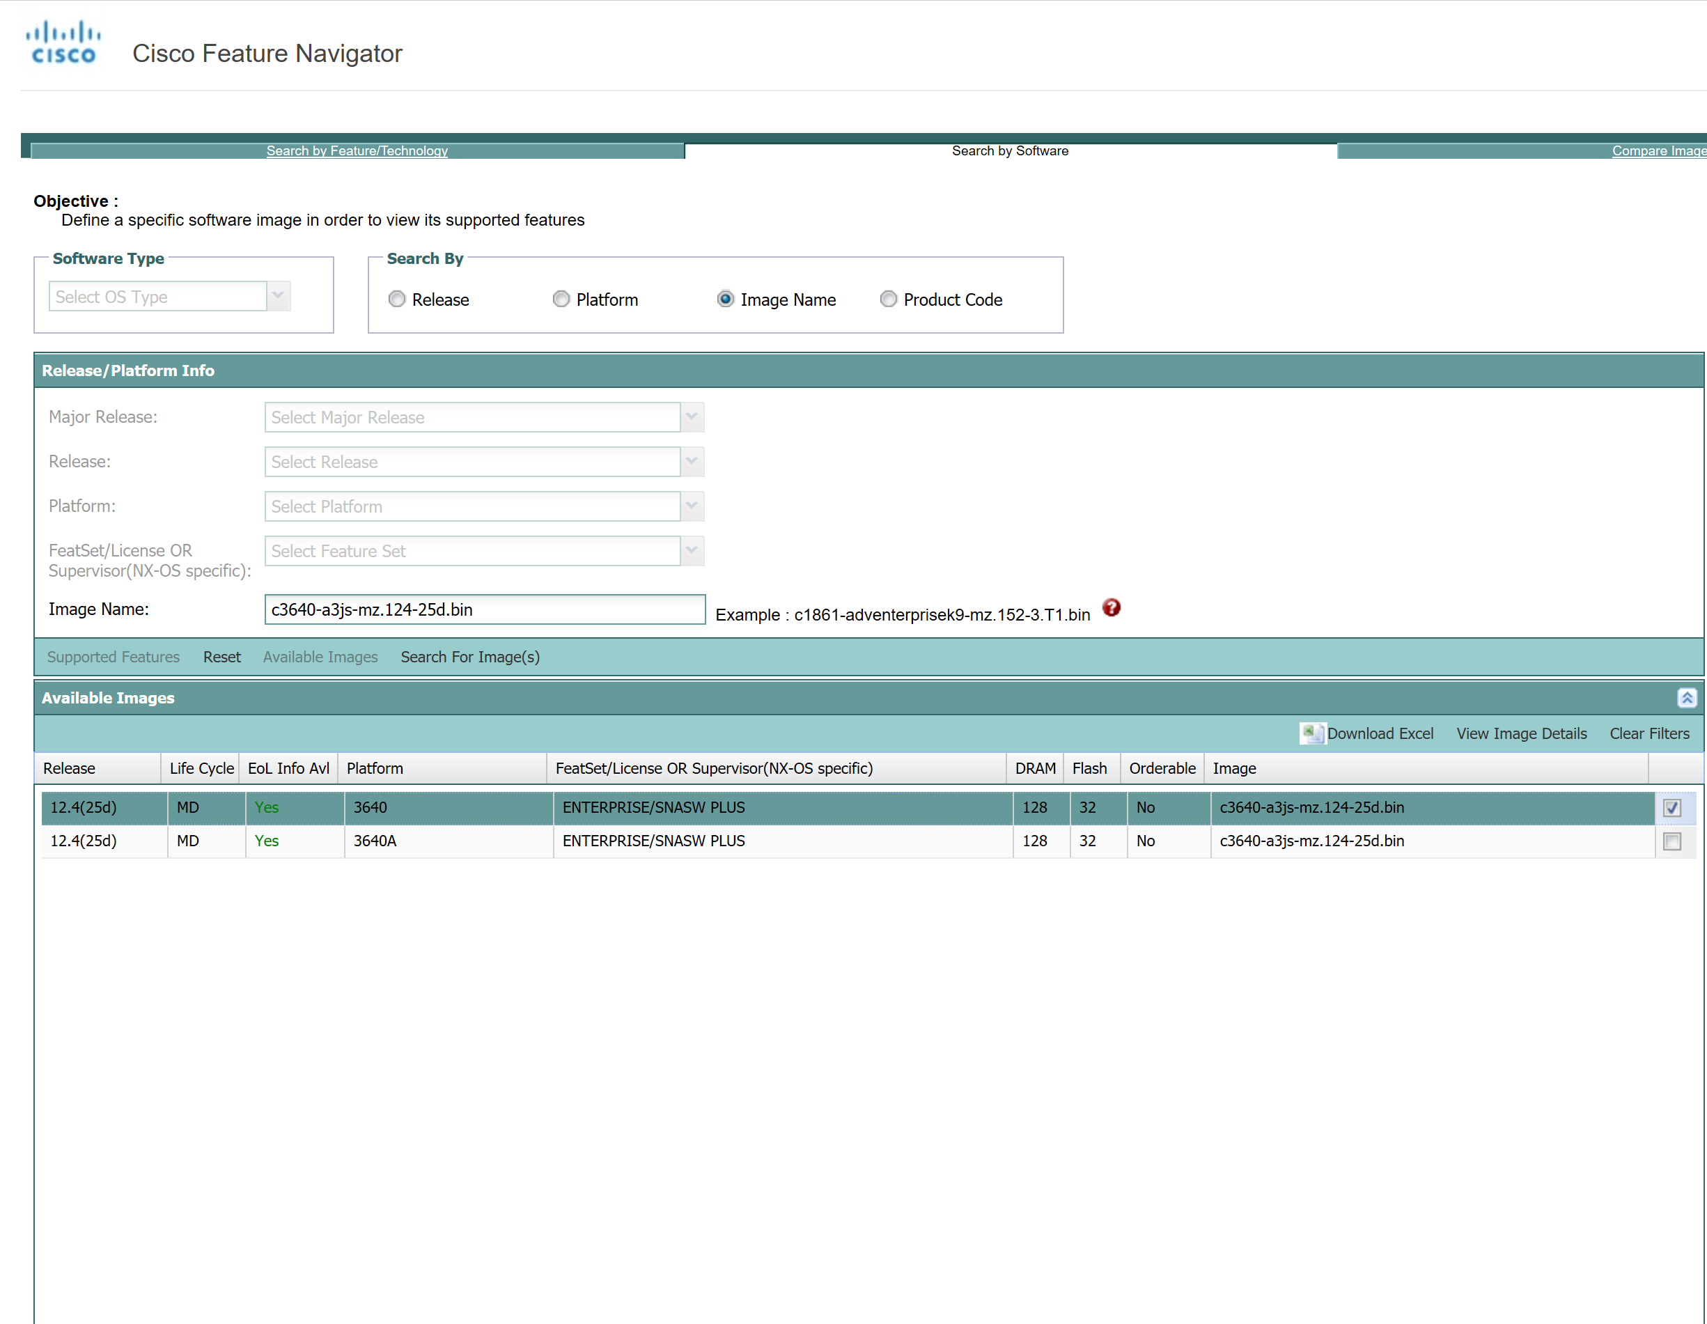

The link will take the user to Cisco’s feature Navigator. Feature Navigator is a platform where the user can gain information on Cisco’s various products. For this lab’s purpose, the user would first need to check the “Image Name” option, then type the name of the image without making a spelling error, and then search for the image’s information. The feature navigator, will then exhibit the information that the user seeks, including the value of the RAM. The user should then put in the exact value in the “Default RAM” tab in GNS3.

## STEP 11: -

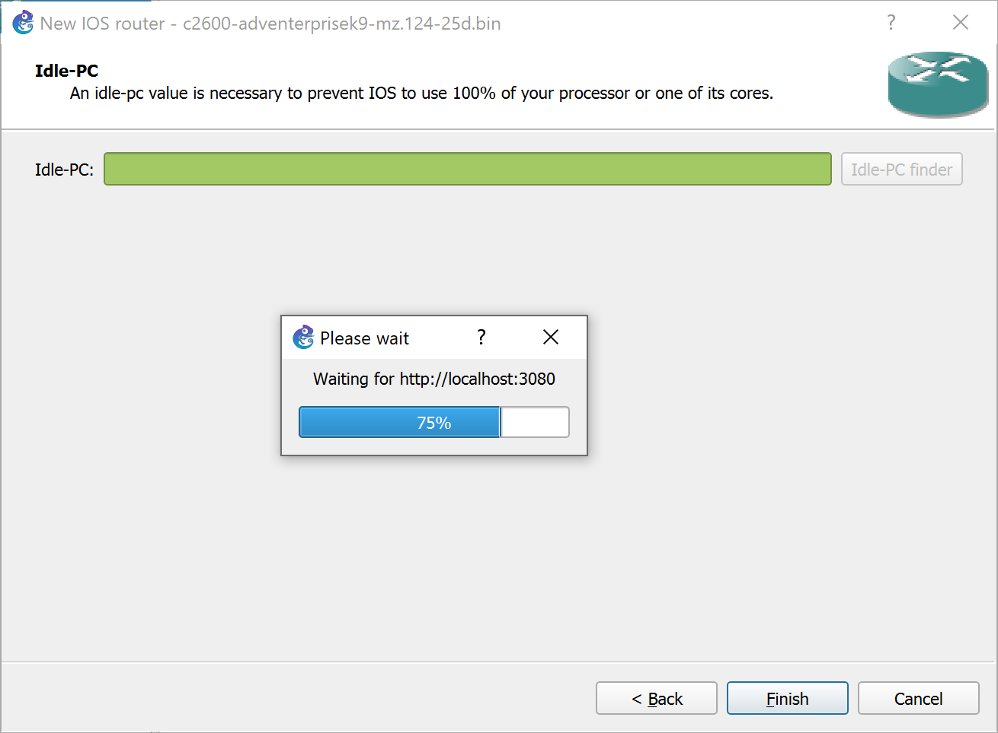

Afterwards, the application will ask the user to employ the interfaces of their choice on the router. The user should research about each interface and install thoughtfully. For this lab, I deployed two “NM-4T” interfaces and two “WIC-2T” interfaces. After that point, the user will be asked to find an Idle-PC value for the router. The user should select the “Idle-PC finder” option to have GNS3 to automatically find a suitable value for the node.

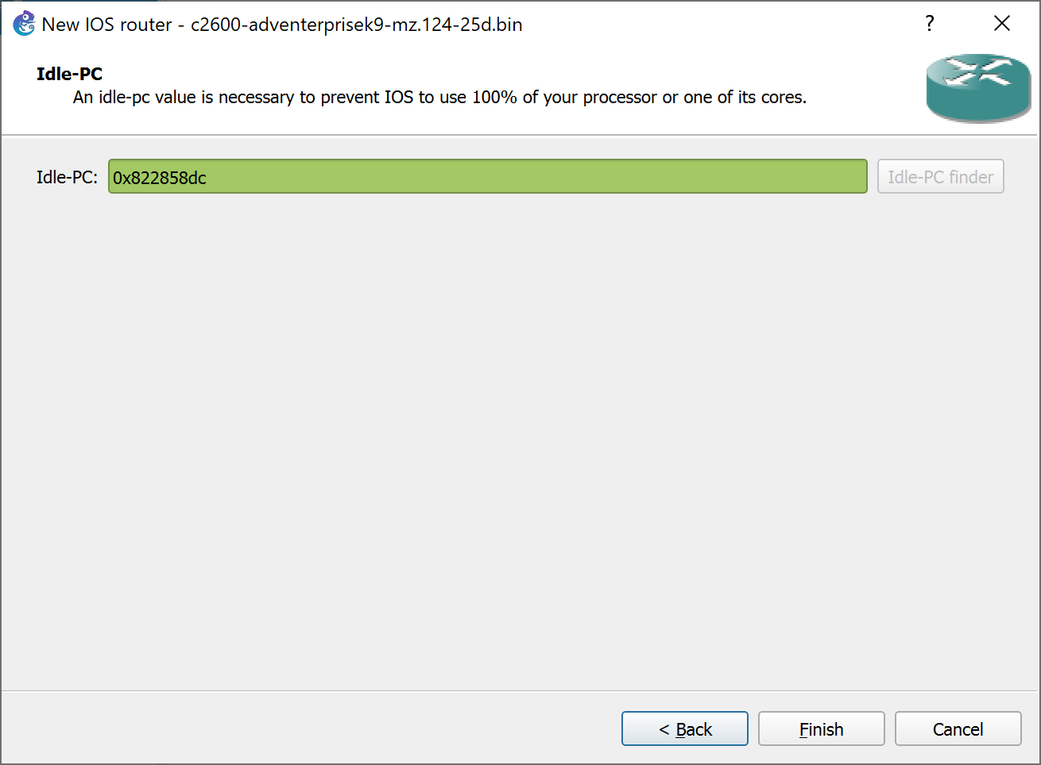

After GNS3 finds a fitting value for the router, select “Finish” to import the router into GNS3.

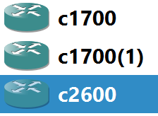

## Step 12: -



Now the user should download the last bit of resource that they need to begin the lab. They should enter the URL mentioned above into address bar, which would prompt them to a window that looks like the following screenshot.

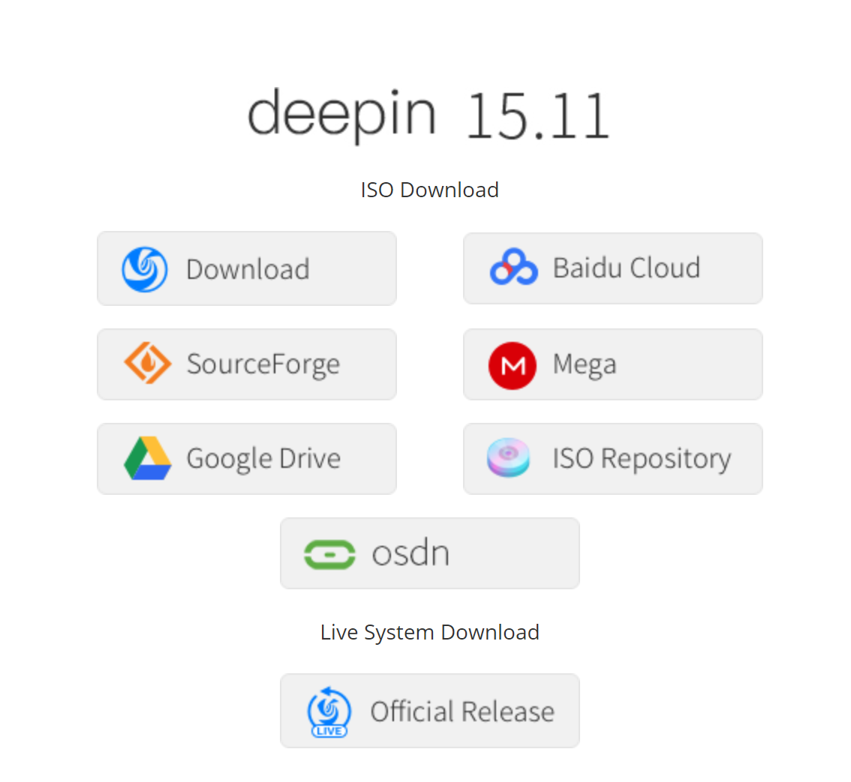

The user must click on the link of their choice that they want to use to download the Deepin OS ISO file.

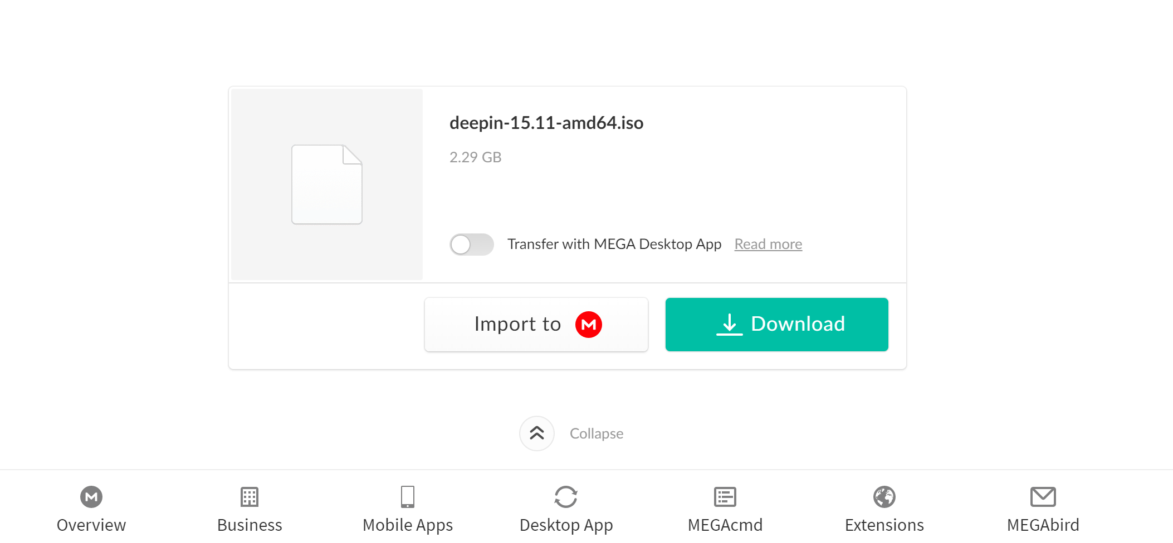

This is what the Mega link looks like. If the user uses the Mega link to download the ISO file, they should simply click the green “Download” button.

## Step 13: -



To insert the Deepin OS into VMWare Workstation, open the Workstation and select the “Create a New Virtual Machine” option.

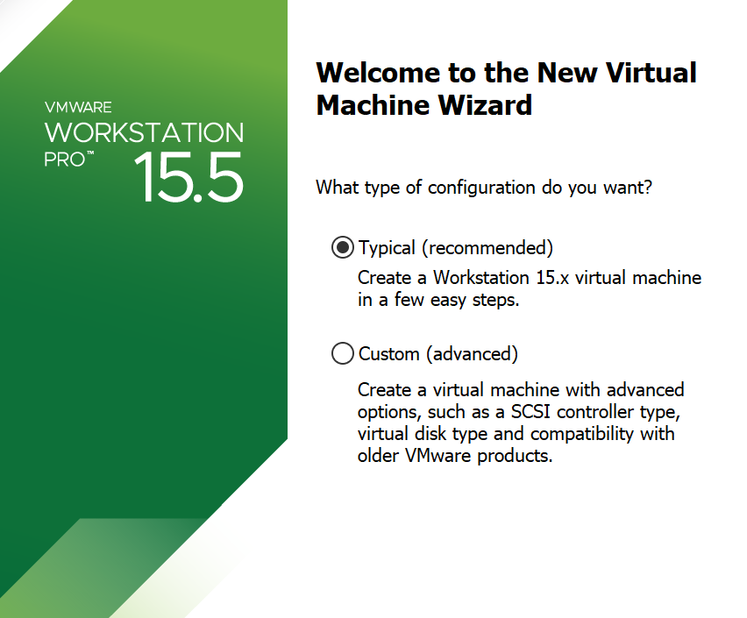

Since we do are not using the VM for any unusual purpose, due to which, we would need to install the VM using our desired settings, we would select the “Typical” settings for the installation.

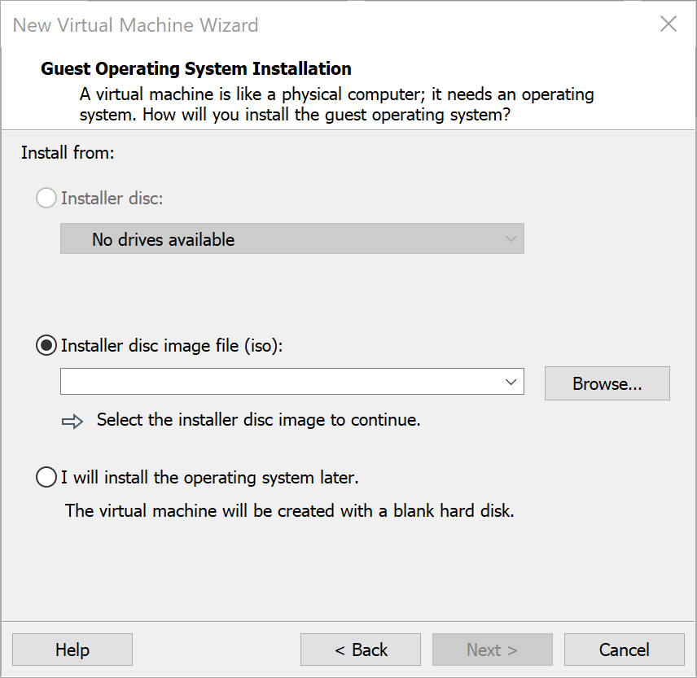

Locate the Deepin OS ISO file to be installed into VMWare Workstation.

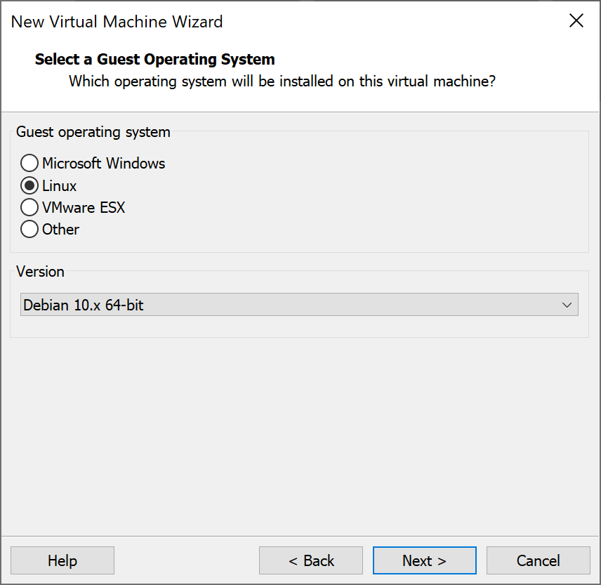

Since Deepin OS is a Debian based Linux distribution, the user must check “Linux” under the Guest operating system and from the dropdown, under Version, select the latest “Debian” version.

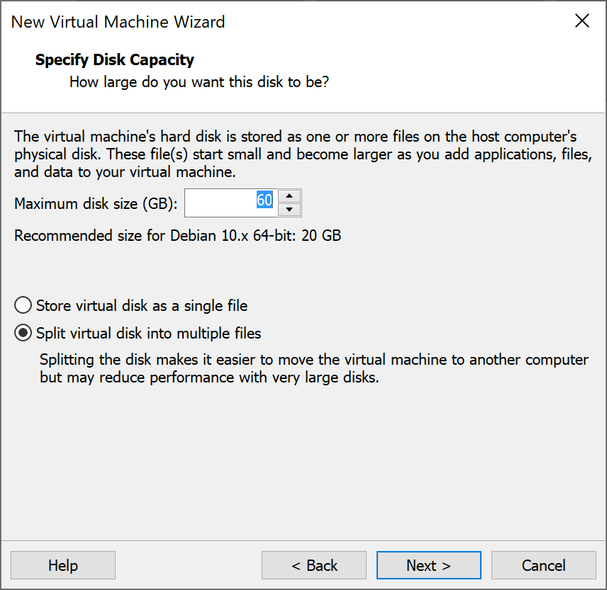

Unlike other Linux based OS, which can operate with 20 GB disk capacity, Deepin needs a larger disk capacity because of its additional DDE environment and applications.

## Step 14: -

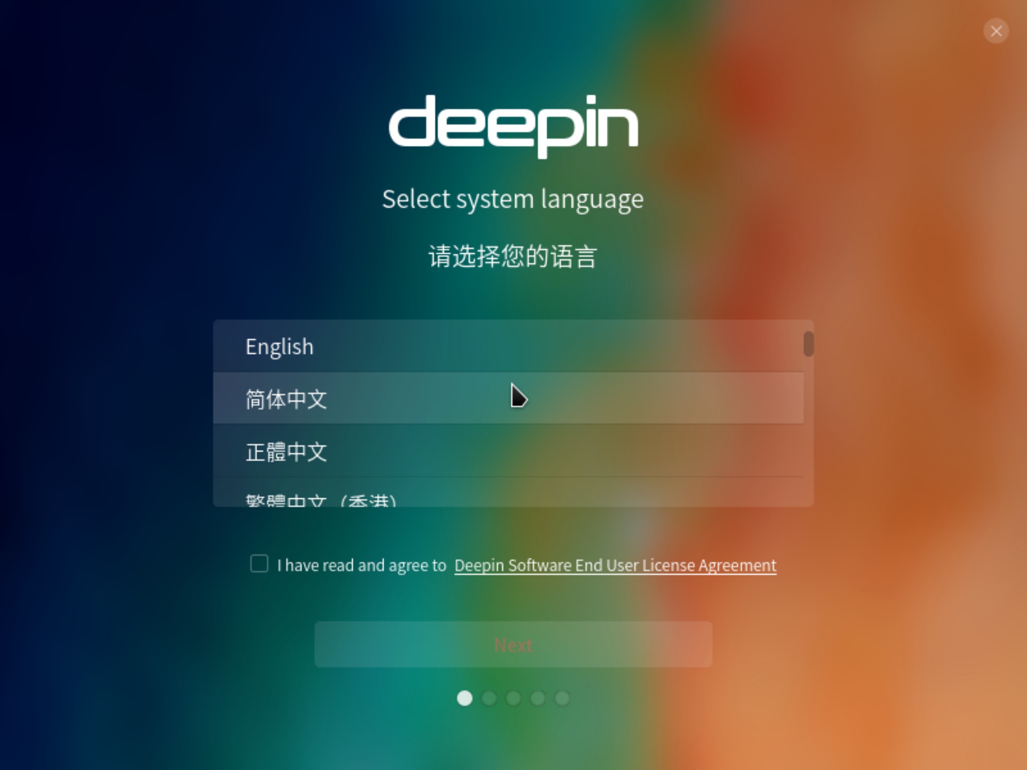

Once Deepin OS has been deployed on Workstation, it is time to install it. The user should begin by selecting the language of their preference.

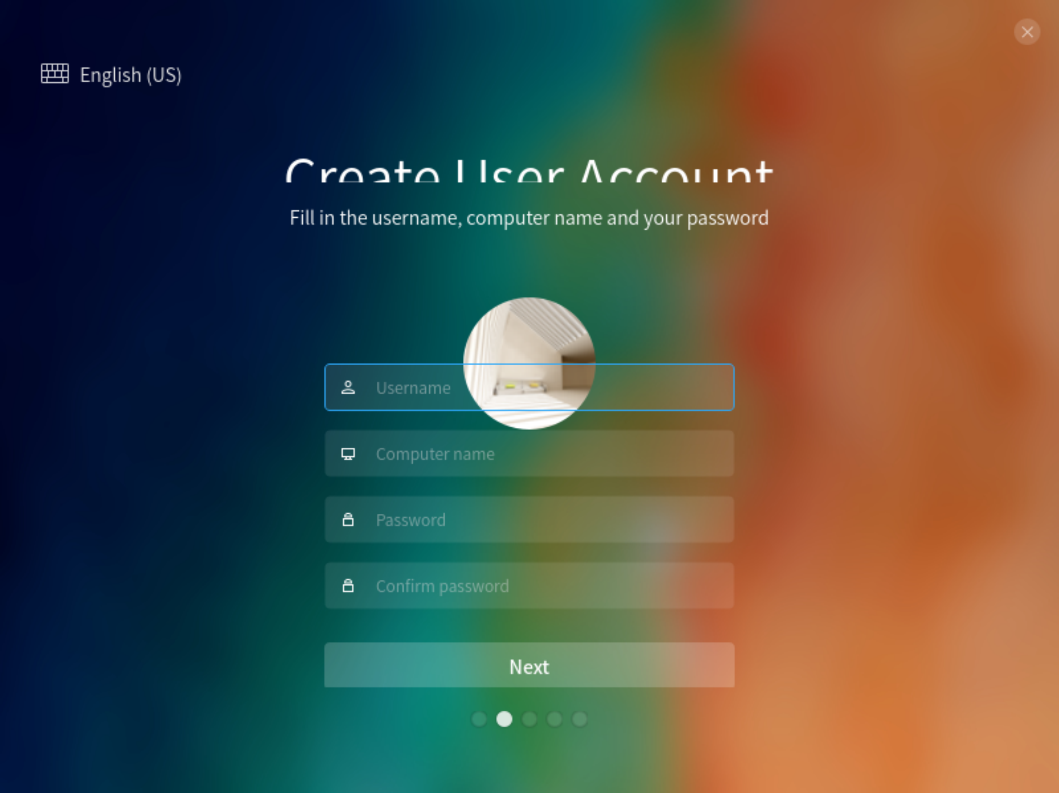

After that the user should set up a username and password that they will use to log into the VM. These credentials must be noted somewhere else as it would be almost impossible to reset them if they are forgotten.

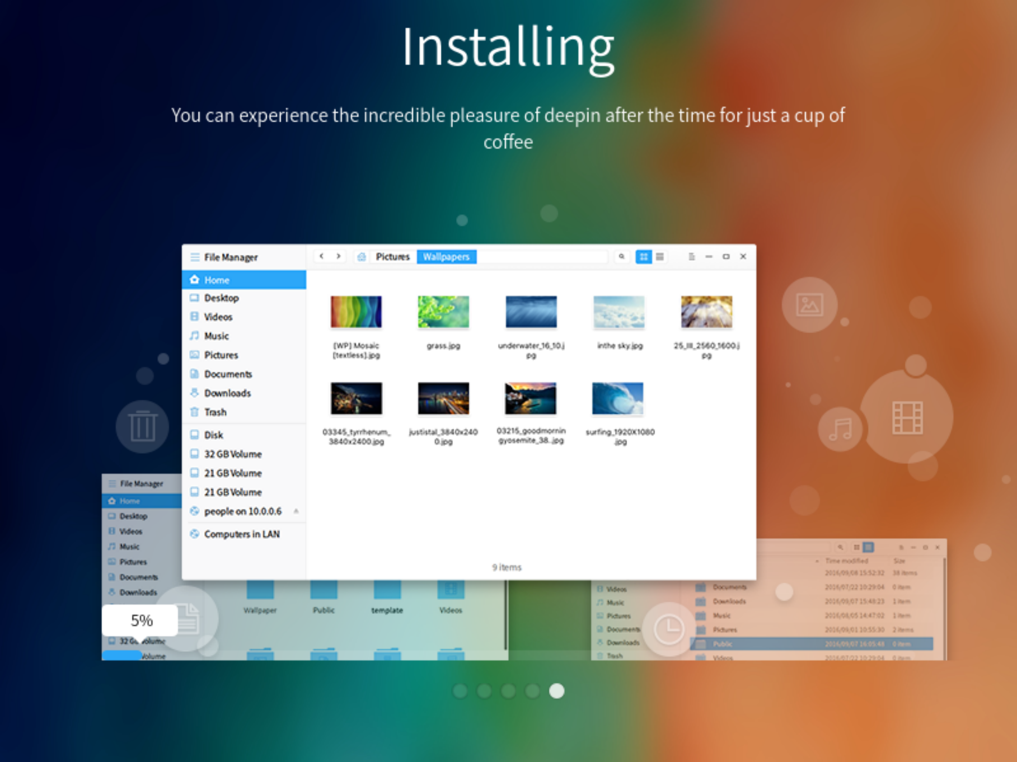

The user must follow the additional installation steps and configure them according to their own preference and let the OS install.

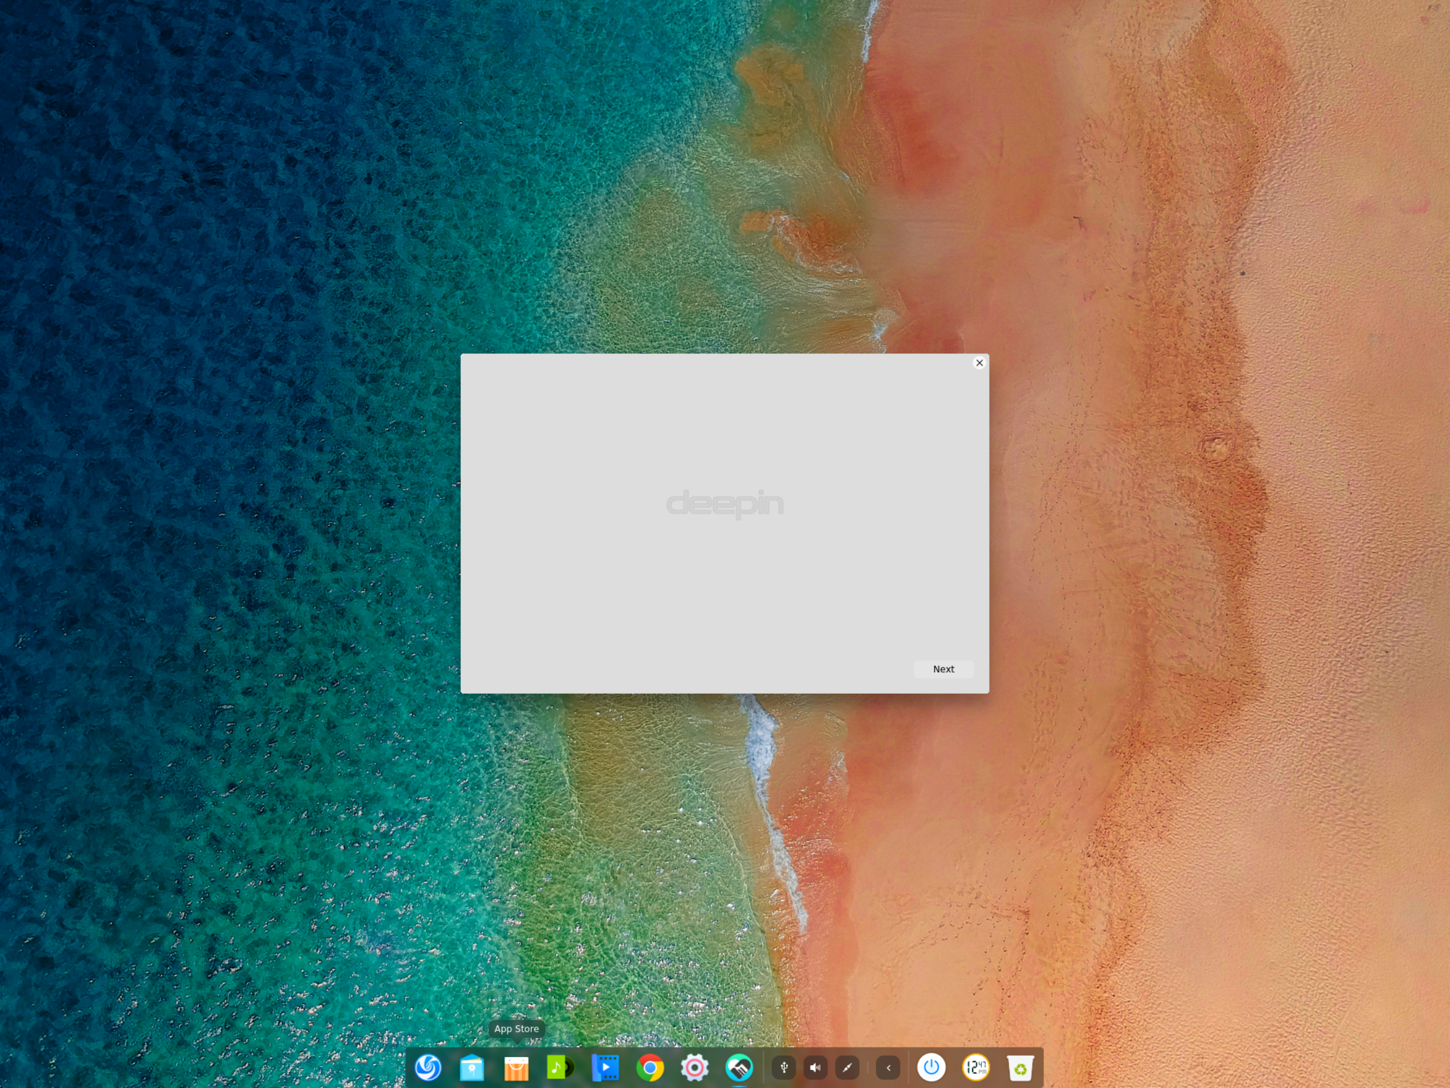

Once installed, the Deepin VM would look like this!

## STEP 15: -

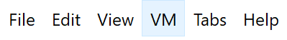

The user must now navigate to VM -> Settings -> Network Adapter.

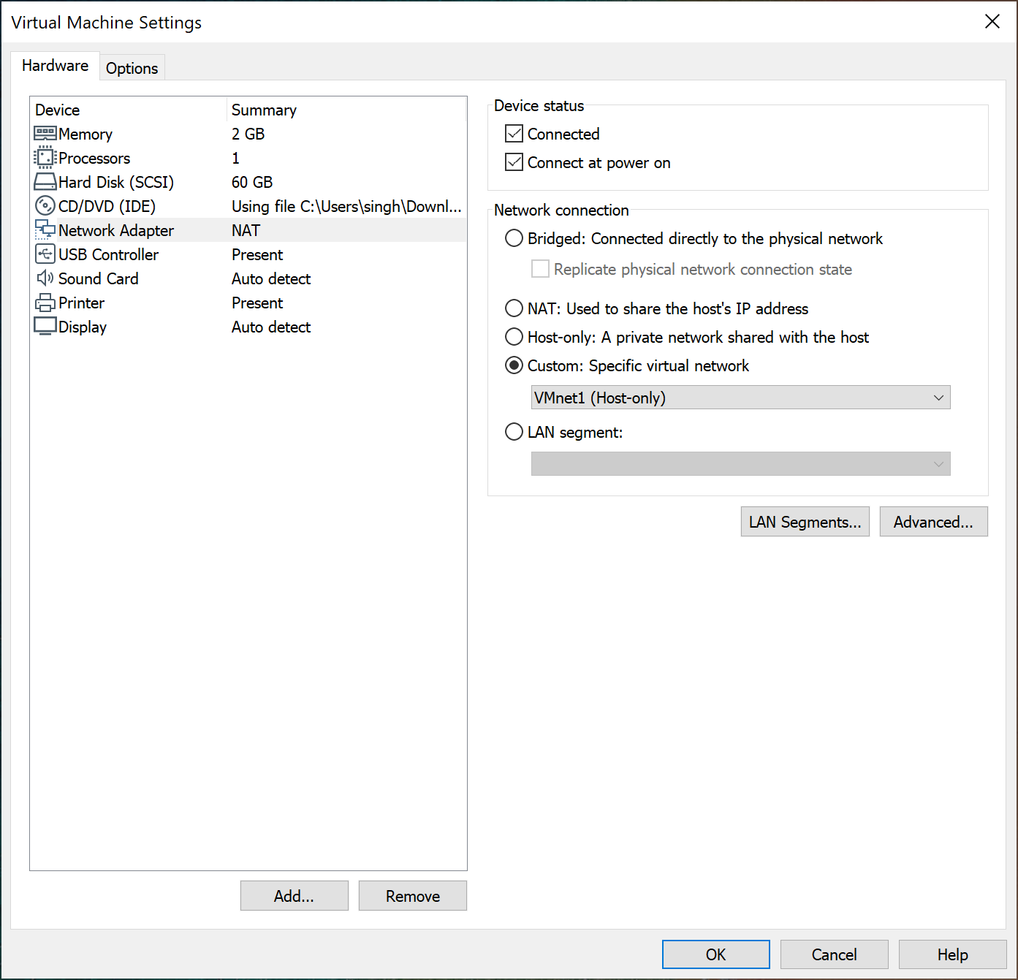

Under Network connection, in the dropdown, select the “Host-Only” interface. It should usually be VMnet1. This setting will make the Deepin VM isolated. It will act as if the VM’s interface port is empty and is not connected to anything. We need the Deepin OS to be at this setting to have it be a part of the GNS3 topology and make connection with the virtual appliances on the application.

## Step 16: -

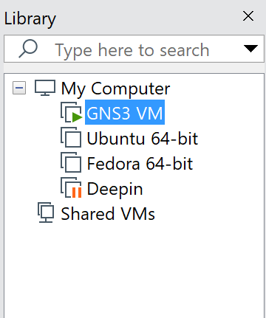

The user must now head over to GNS3 VM in the Workstation and navigate to VM -> settings, and select “Add…”

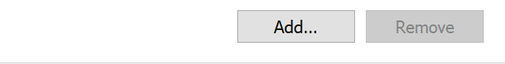

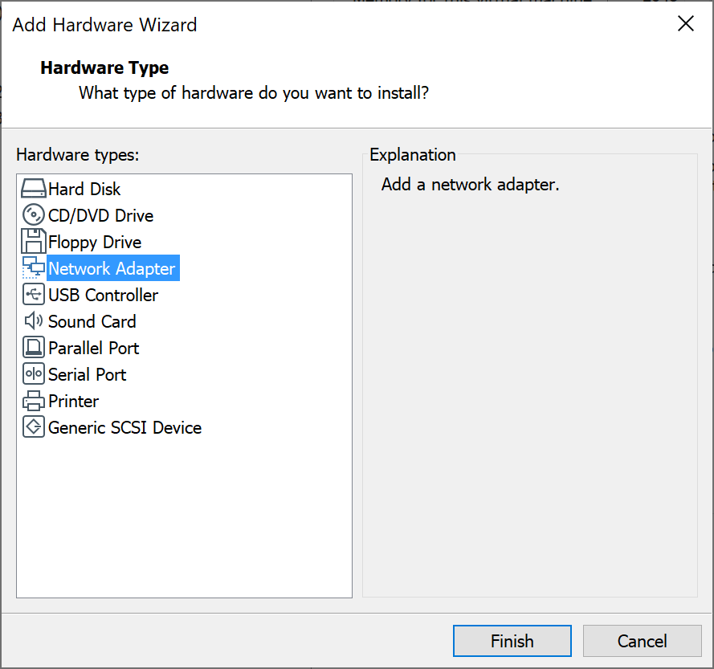

Add a network adapter to the GNS3 VM and select “Finish.”

## Step 17: -

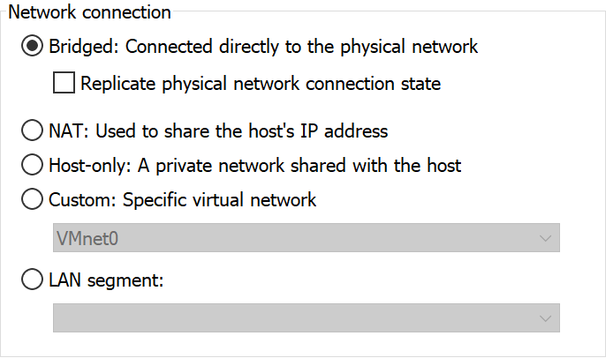

Under that new network adapter’s network connection, check the “Bridged: Connected directly to the physical network” option. That way, the new network adapter, i.e. network adapter 3, will be bridged with the Physical PC and will replicate its connection(s). The user will later use this interface to connect the router and the Deepin VM to the internet.

## Step 18: -

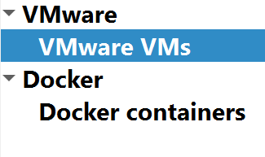

Head over to GNS3 and go to edit -> preferences and under “VMWare,” locate “VMWare VMs,” and select “New.”



## Step 19: -

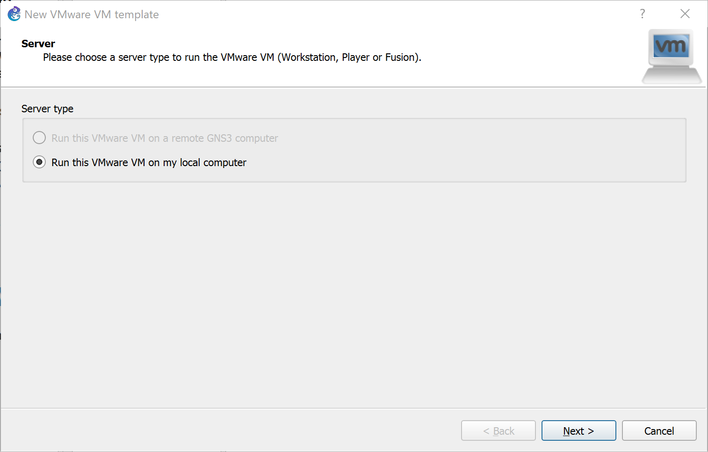

Check the “Run this VMware VM on my local computer” option for GNS3 to find the Deepin VM on the user’s end host.



From the VM list dropdown, select the name of the VM that you want to install in GNS3. It should be the whatever the user has named the Deepin VM. Once the user has deployed the VM in GNS3, they would be able to locate it under “All Devices.”

## Step 20: -

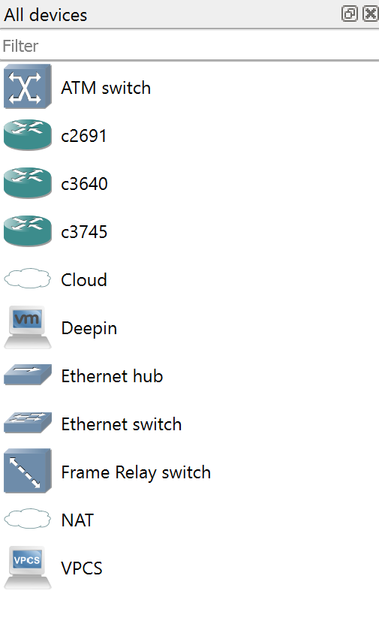

From “All devices,” drag and drop any router and the Deepin VM into the topology and make a connection between them.

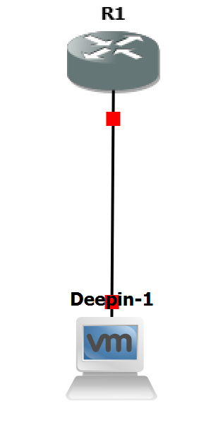

## Step 21: -



Select the “Cloud” and drop it into the topology. Select the Cloud and click on “Configure.”

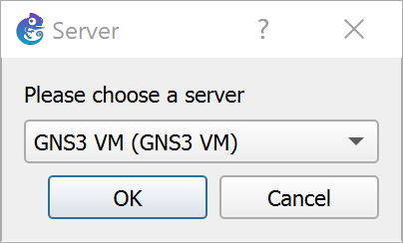

From the dropdown, which asks the user to select a server, select the GNS3 VM. Connect the router to the **e3/0**interface of the Cloud. Due to this, the router will now be connected to the 3rd network adapter of the GNS3 VM, which is bridged with the physical topology.

## Step 22: -

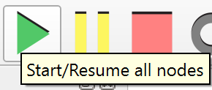

Click on the green triangle on the top left corner of the GNS3 window, to start all the devices in the topology.

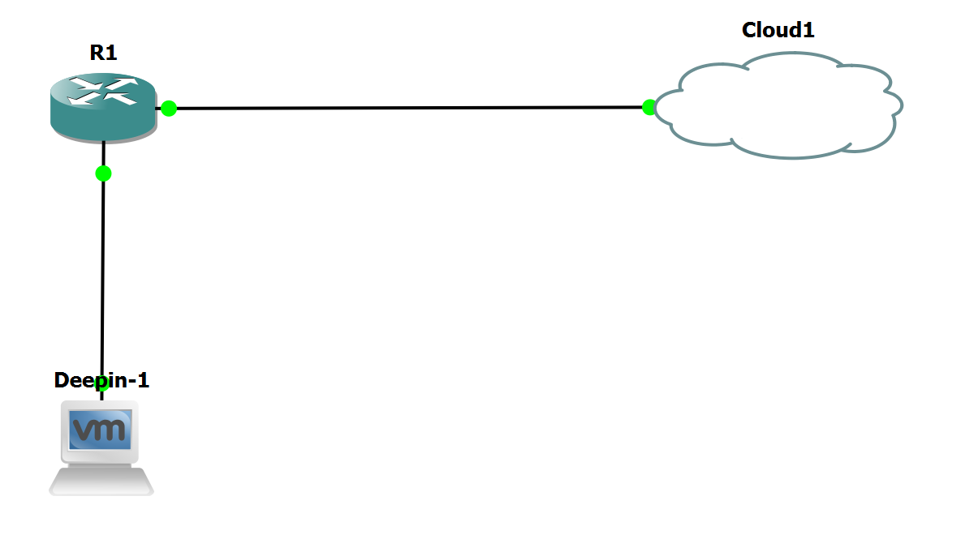

After waiting a few seconds, all the links should go online, and the topology should look like this! This is what the topology on GNS3 would look like

## Step 23: -

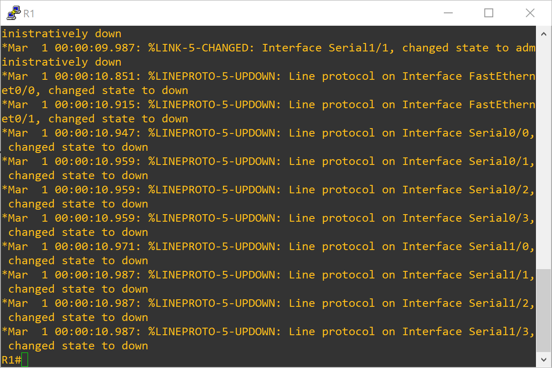

Click on R1 and select Console to open a putty session. Navigate to the interface that connects to the cloud using the interface *{interface-id}* command in the Global-config mode. The user would want this interface to be set up to be a DHCP client. The user must configure to make this interface to obtain a DHCP address from the ISP using the IP Address DHCP command. After waiting for a while, R1 will show the user the message that indicates that it has obtained an IP address.



## Step 24: -



The user must hop on to the actual PC and open a command prompt session. Execute an Ipconfig /all and note the IP address of the DNS server(s).

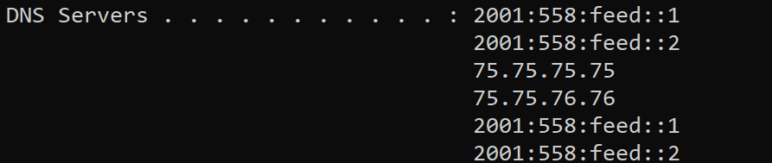

Head back to the router and enter the IP name-server *{DNS Server’s IP address}* command in the global-config mode. This command will make the router a DNS client and it will request and then receive DNS packets form that server. At this point, the router should be connected to the internet. The user can test that by trying to ping a known domain on the internet. As one can see from the following screenshot, I was able to successfully ping “Google.com.”

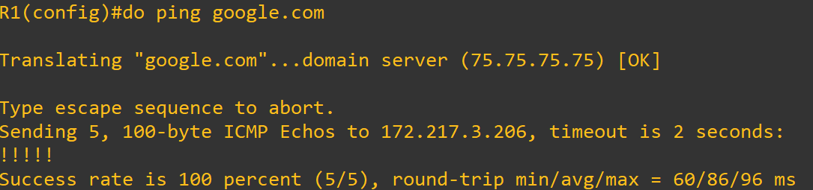

The user must note that they must enable the IP domain-lookup command in the global-config mode in order to ping domains.

## Step 25: -

Now that the router is connected to the internet, does not necessarily mean that the router’s connections too can connect to the internet. Since the router is connected to an outside network, it needs to perform some sort of NAT. Before the user does that though, the user needs to assign an IP address on the interface connected to the Deepin VM. Use the Interface *{interface-id}* command in the global-config mode of the router to enter the interface-config mode. In the interface-config mode, enter the IP Address *{IP Address} {Subnet mask}* command.

Now, to configure PAT, the user would need to first create a standard ACL that permits all and any kind of traffic originating from the Deepin network. To achieve that, the user must enter the Access-list *{Access-list 1-99}* permit *{network address} {wildcard bits}* command in the global config mode. The use must note that the network address in that command should be the network address of the Deepin network. The user must then enter the IP NAT inside source list *{access-list id}* interface *{interface id that connects to the cloud}* overload command in the global-config mode. To end this step, the user must execute the IP NAT inside command on the interface that links to the Deepin VM, and IP NAT outside on the interface that connects to the cloud, in their respective interface-config mode.

## Step 26: -

Start the Deepin VM and from the list of applications, open the click on the control center icon.

The user should then click on the “Network” icon.

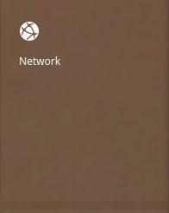

Under network, click on “Wired Network.”

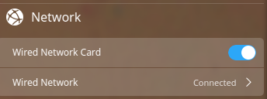

Under the IPv4 section, select the “Method” option.

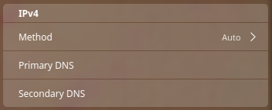

Change the IPv4 address method from Auto to Manual.

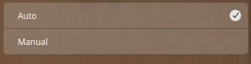

Change the IP address and the subnet mask to have the VM connect to the router, and configure the VM to become a DNS client by manually entering the IP address(es) of the DNS server noted in STEP 24.

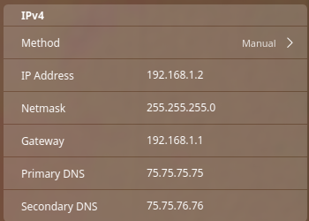

The following screenshot exhibits that the VM should be able to reach the internet at this point.

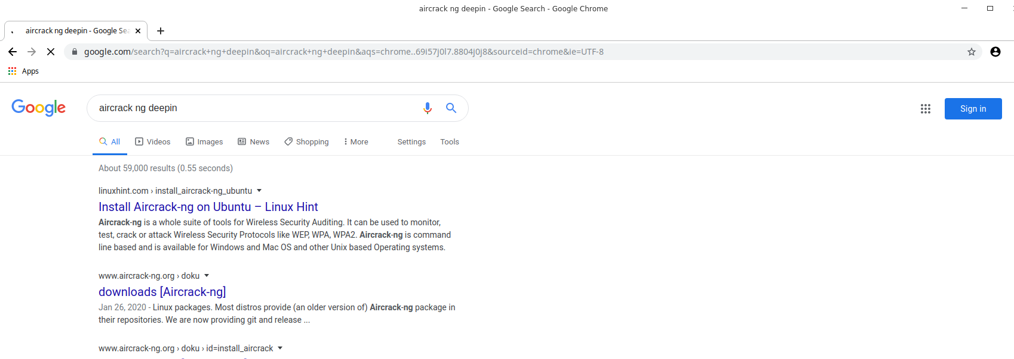

## STEP 27: -

Now, that the Deepin machine is connected to the internet, the user should install the tools that they need to complete the lab.



At the bottom of the Deepin screen is the launcher overlay, where the user can find multiple applications to run. For the lab, however, the user would need to locate the Terminal. The terminal icon in Deepin looks different from the Terminal icon in other Linux OS, because the Deepin OS does not have the traditional Linux Terminal. Deepin OS has its own version of a Terminal, known as Deepin Terminal, which also happens to be a part of the DDE.



The first tool, and the most important tool, that we need to install on our Linux machine is the “Aircrack -ng Suite.” The user should be able to install the suite using the command exhibited in the screenshot.



The other tool that we need to install is the Macchanger tool. The user does not necessarily need to download the macchanger tool because the macchanger tool cannot help in cracking the Wi-Fi encryption or spamming it with the Deauthentication frames. Macchanger is used to fake the interface’s Mac address, and it is just used to maintain the lab’s authenticity.

## Step 28: -



The user should now enter the administrator mode in the Terminal because they will be making changes to the machine in the following steps. They must enter the command shown in the above screenshot to enter the admin mode.

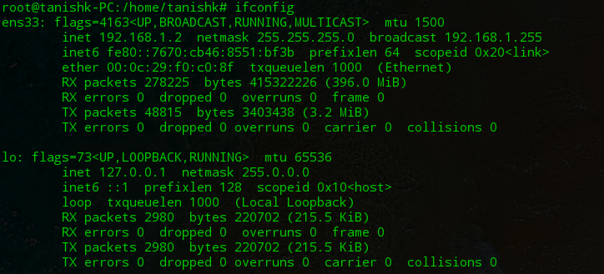

The user would now want to know the name of the interface that they will be affecting. An Ifconfig command can help the user with this issue. After executing the command, the user would need to check for the interface that has the IP address that they statically set on the machine in STEP 26. The interface that has that IP address, will be the interface that they must be looking for. In this case, “ens33” is the interface that I will be using to send the frames.



The user would need to set the interface down using the command shown in the screenshot.

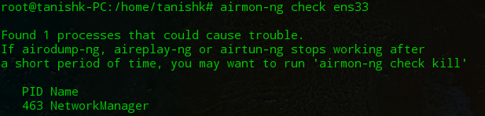

The command executed in the screenshot above, shows the processes that can cause trouble in our lab. So, before the user starts sending the deauthentication frames, they would need to kill the process(es) that might create some conflicts. In this case, the “NetworkManager,” which is running on PID 463, could have potentially caused a few problems for me during the remainder of the lab.



The user can use wither of the executed commands to kill the programs that could have caused problems. The user must remember, however, that the kill 463 command is basically kill *{PID value}* command. The user will need to replace the number 463 in the command with the PID process that they wish to kill.

## Step 29: -

The user will now need to know the MAC address of the WAP in order to continue performing the lab. To do that, the user will need to use the physical machine and open a command prompt window.

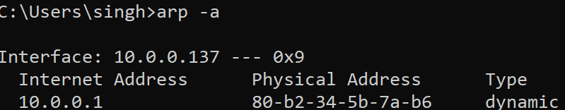

The user will need to execute an Arp -a command to know the MAC address of all the devices in the LAN. This command floods the Arp packets to all the devices in the network, due to which, the user can recognize all the devices, by their MAC address. In this case, the user will need to find the MAC address that corresponds to their WAP’s IP address, and note it down.

## Step 30: -



The user should hop back to the Deepin VM and start making a script. Before, the user makes the script, they would need to place it in a directory. The first command exhibited in the screenshot, lets the user enter a directory. Since I executed a cd Desktop/ command, I will be placing my script on the Desktop. The user can place it an elsewhere directory. The second command is used to create a file. “Dos.sh” is the name of my script. The user can name it something, but they must keep the extension, i.e. the “.sh” extension.

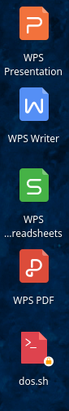As one can see in the screenshot that the new file that I created, could be found in the Desktop.

## Step 31: -



The user can now begin editing the script according to their desires. The command shown in the screenshot, lets the user enter the script and make changes to it.

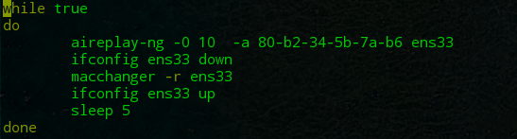

1

2

3

4

5

This script will let the user complete a Wi-Fi deauthectication attack on a WAP. The first statement, while true, lets the user perform a given set of commands an unknown number of times as long as the given condition evaluates to true. This statement will let the script execute on loop. The do statement marks the actual beginning of the script. The first command after the “do” statement, sends the deatuthentication frames to the WAP. The censored part of the command is the MAC address of the WAP that the user noted in STEP 29. The second command will set the interface down, and the third command will assign the interface a new and fake mac address. The fourth command will set the interface running again, and the last and the fifth command, will let the machine rest for 5 seconds, before executing the script again. The last statement, done, marks the end of the script. The script will send keep sending Deauthentication frames to the WAP and assign the interface a new MAC address after that. This will happen repeatedly until the user stops the script using the CTRL+Shift+6 hotkey. In this step, the user has only made the script, but has not executed or performed it.

## STEP 32: -

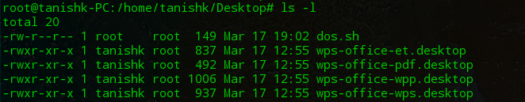

The command executed in the screenshot above, shows that the script does not have the ability to be executed as it does not have the admin powers.



The command exhibited in the above screenshot, gives the script the admin powers.



At this point, there is no other step that the user will need to do. All that is remaining is to execute the script and let the DoS attack happen. The user would use the command shown in the screenshot to execute the script.

## Results: -

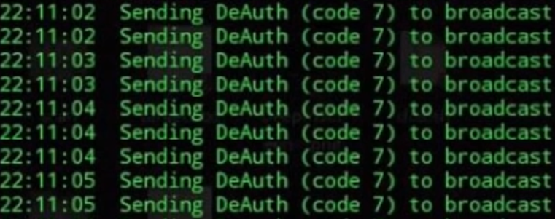

This screenshot shows that the Deauthentication messages are being sent to the WAP and all the users connected to the WAP, would soon begin facing problems connecting to the internet.

## Configuration

## R1: -

hostname R1

boot-start-marker

boot-end-marker

no aaa new-model

memory-size iomem 5

no ip icmp rate-limit unreachable

ip cef

ip auth-proxy max-nodata-conns 3

ip admission max-nodata-conns 3

ip tcp synwait-time 5

interface FastEthernet0/0

ip address dhcp

ip nat outside

ip virtual-reassembly

duplex auto

speed auto

interface Serial0/0

no ip address

shutdown

clock rate 2000000

interface FastEthernet0/1

ip address 192.168.1.1 255.255.255.0

ip nat inside

ip virtual-reassembly

duplex auto

speed auto

interface Serial0/1

no ip address

shutdown

clock rate 2000000

interface Serial0/2

no ip address

shutdown

clock rate 2000000

interface Serial0/3

no ip address

shutdown

clock rate 2000000

interface Serial1/0

no ip address

shutdown

serial restart-delay 0

interface Serial1/1

no ip address

shutdown

serial restart-delay 0

interface Serial1/2

no ip address

shutdown

serial restart-delay 0

interface Serial1/3

no ip address

shutdown

serial restart-delay 0

ip forward-protocol nd

no ip http server

no ip http secure-server

ip nat inside source list 1 interface FastEthernet0/0 overload

access-list 1 permit 192.168.1.0 0.0.0.255

no cdp log mismatch duplex

control-plane

line con 0

exec-timeout 0 0

privilege level 15

logging synchronous

line aux 0

exec-timeout 0 0

privilege level 15

logging synchronous

line vty 0 4

login

end

## Problems

I faced quite a few problems while doing this lab. Since I was entering sort of like a new territory in every step, I faced problems in almost every step. The first bit of problems that I faced were with the working of GNS3. GNS3 is a very complicated software, especially for someone who would have just started on it. I had tried GNS3 in the past before, but gave up on it because of its complicity. This time, however, due to the situations, it became necessary for me to research and get the application up and running. The major problem that I had, which seemed very confusing in the beginning, was the GNS3 VM. Whenever I would start the application, GNS3 would begin searching for the GNS3 VM, and it got very irritating to see the timeout warning message appear every 5 seconds or so. To solve that problem, I researched a bot about GNS3 VM and found it to be a useful resource in the future. I, then, researched for a way to download the GNS3 VM and get it up and running. I found the answers to my question on GNS3’s website’s FAQ section.

The second major problem I had was with the selection of the attacking OS. I wanted to experience working with the Deepin Terminal, and I looked for ways to install it on other Linux OS. I first tried my luck on Kali Linux. After researching for a while, I could not find any source, which would explain how I could download the DDE elements in Kali. I, then, switched to Fedora. It was said that a user can download the DDE elements in Fedora, and so I did. Fedora, however, had a problem with its workability as it would constantly keep crashing. In the end, I decided to use the Deepin OS as it would be the best way to work with the DDE.

While trying to connect the my Deepin OS to the internet through R1, I was confused how I would be able to make adjacencies with the WAP. While I thought about that process, I realized that the router does not need to create adjacencies with the WAP as it was connected to the GNS3 VM, which was bridged to my physical network, and so I just connected the Deepin VM to R1 and configured the network interface on Deepin, with the hopes of connecting it to the internet. That was not sufficient, however. I, later realized, that I needed to do some sort of NAT on R1 to have the Deepin VM connect to the internet. After I completed performing NAT on R1, my Deepin VM could connect to the internet.

## Conclusion

DoS is usually aligned with hacking or heinous cyber-attacks. It is probably one of the most dangerous attacks that can happen on a network. Of course, the intention behind doing this lab was not to learn this skill to become a professional cybercriminal. Although DoS attacks are very difficult to mitigate, but it is still possible. Every DoS attack can be mitigated or eliminated using different tactics and methods, but there are a dew basics. To start with this explanation, I would like to explain how one could prevent a Wi-Fi Deauth attack.

WPA2-AES encryption is deemed to be the best encryption to this date, and there is almost no way of cracking the encryption. The attack that was done in this lab, happened due to a weak encryption. Now, one must just rely on encryption methods. The best way to prevent the attack done in this lab is to have one’s WAP encrypted with the best encryption and place a firewall with the correct configuration between the ISP site and the WAP. A firewall with the correct configuration can help in many ways. If this attack has taken place on a person’s WAP, however, then they should unplug the WAP and follow all the mentioned prevention methods.

Although DoS has become widely popular thanks to a few television series and movies, which have also influenced some kids and teenagers to learn the skill and use it to cause some ruckus, it takes a smart brain to stop the attack. I believe that the first and foremost step that a person should follow while getting affected by DoS/DDoS attack is to calm themselves down and think. Stopping these attacks, depends solely on strategies. Even a normal approach like implementing access lists can save a network from getting affected by a DoS attack. The intention behind doing this lab was to understand how these attacks work and understand how we can save ourselves from them if it happens to take place on our network/devices.